

Group 13, Report 4:

**Design & Implementation of a**

**Data Warehouse for a Retail Store**

Saurabh Bhalla, Evan McClintock, Abhinav Verma

ISYS 637-602

May 2, 2017

# Team Task Sheet

|  |  |
| --- | --- |
| **Saurabh Bhalla** | |
| **Task Description** | **Duration** |
| Research | 9.00 hours |
| Explore Metadata | 5.00 hours |
| JMP & Excel & Access Experimentation | 10.00 hours |
| Question Development | 8.50 hours |
| Report 1 Content | 14.50 hours |
| Dimensional Modeling & Design Process | 14.00 hours |
| Business Question Justification & Review | 2.50 hours |
| Visio Diagrams | 3.50 hours |
| Report 2 Content | 3.50 hours |
| Database Creation and Management | 1.00 hours |
| ETL Plan | 3.00 hours |
| ETL Implementation | 16.00 hours |
| Cube Development | 4.00 hours |
| Designing SSAS & SSRS Reports | 12.00 hours |
| Finishing SSAS Reports | 9.00 hours |
| Report Builder Reporting | 6.00 hours |
| Report 3 Content | 5.00 hours |
| Report 4 Content | 8.00 hours |
| Total Time Spent | **134.50 hours** |

|  |  |
| --- | --- |
| **Evan McClintock** | |
| **Task Description** | **Duration** |
| Research | 12.00 hours |
| Explore Metadata | 7.00 hours |
| JMP & Excel & Access Experimentation | 17.00 hours |
| Question Development | 6.50 hours |
| Report 1 Content | 15.00 hours |
| Dimensional Modeling & Design Process | 12.00 hours |
| Business Question Justification & Review | 2.75 hours |
| Visio Diagrams | 5.00 hours |
| Report 2 Content | 10.00 hours |
| Database Creation and Management | 3.00 hours |
| ETL Plan | 7.00 hours |
| ETL Implementation | 25.00 hours |
| Cube Development | 4.00 hours |
| Designing SSAS & SSRS Reports | 4.00 hours |
| Finishing SSAS Reports | 10.00 hours |
| Report Builder Reporting | 2.00 hours |
| Report 3 Content | 8.00 hours |
| Report 4 Content | 8.00 hours |
| Total Time Spent | **158.25 hours** |
|  |  |
|  |  |

|  |  |
| --- | --- |
| **Abhinav Verma** | |
| **Task Description** | **Duration** |
| Research | 8.00 hours |
| Explore Metadata | 4.00 hours |
| JMP & Excel & Access Experimentation | 12.00 hours |
| Question Development | 7.00 hours |
| Report 1 Content | 13.75 hours |
| Dimensional Modeling & Design Process | 11.50 hours |
| Business Question Justification & Review | 2.75 hours |
| Visio Diagrams | 3.00 hours |
| Report 2 Content | 4.00 hours |
| Database Creation and Management | 1.00 hours |
| ETL Plan | 20.00 hours |
| ETL Implementation | 3.00 hours |
| Cube Development | 4.00 hours |
| Designing SSAS & SSRS Reports | 8.00 hours |
| Finishing SSAS Reports | 8.00 hours |
| Report Builder Reporting | 2.00 hours |
| Report 3 Content | 4.00 hours |
| Report 4 Content | 5.00 hours |
| Total Time Spent | **121.00 hours** |
|  |  |
| **GROUP TOTAL :** | **413.75 hours** |

**We agree that hours reported on these pages accurately reflect our individual assigned tasks, effort, and participation in this project.**

|  |  |  |  |  |
| --- | --- | --- | --- | --- |
|  |  |  |  |  |
| **Saurabh Bhalla** |  | **Evan McClintock** |  | **Abhinav Verma** |

Table of Contents

**1. Introduction1**

**2. Understanding the Source Data**2

**3. Retail Domain Understanding3**

**4. Business Questions4**

**5. Build the Matrix18**

**6. Design and Justify Each Fact Table19**

**7. Design and Justify Each Dimension Table21**

**8. Entity-Relationship Diagrams23**

**9. ETL Plan27**

**10. ETL Implementation32**

**11. BI Reporting 51**

# 1. Introduction

Dominick’s Finer Foods is a major grocery chain that is exclusive to the Chicagoland area. Dominick’s corporate philosophy is to serve its customers by providing “Fresh Values”, a tradition started by Dominick DiMatteo in 1925 when he founded his family grocery chain. The store has now transferred to a new generation of the DiMatteo family who are seeking advice from Century Tree Consulting Group who will provide their family grocery chain with a new data warehouse. This data warehouse will help them make key business decisions regarding the future of their chain, its products, and marketing programs.

This data warehouse will provide Dominick’s with a critical decision support system. Furthermore, this system will help the DiMatteo family in their relationship with Dominick’s suppliers, store managers, and customers. The decisions made through using this new data warehouse will provide Dominick’s a competitive advantage over its major rivals including Kroger and Jewel-Osco. This new competitive advantage could make Dominick’s a valuable target for a potential acquisition. The DiMatteo family eventually wishes to exit the grocery business since their father did not train them in how to continue the family business (Crown, 1993).

This report documents the tasks our team, Century Tree Consulting (Group 13), has completed to create a conformed data warehouse schema for Dominick’s Finer Foods, according to Ralph Kimball’s dimensional modeling methodology. In addition, this report further documents our ETL Design and implementation processes in depth.

Now that our group has designed the star schemas for the data warehouse according to the principles of dimensional modeling in a manner that best answers our business questions, we will ensure the project goals are fulfilled through the extract, transform and loading of the source data for the warehouse. Our team has been instructed by Dominick’s to use HOLAP style for the data warehouse, Microsoft® SQL Server® 2012, and use SSIS for the ETL implementation.

The following business questions, which Dominick’s wants our team to answer are detailed further in section 4.

*Question 1: Which products do we promote in our highest grossing stores?*

*Question 3: What strategies can we implement to make sure in-house brands sell more? How does Dominick’s in-house soda brands fare against a commercial brand like Pepsi?*

*Question 5: Analyze canned soup seasonality patterns to target business strategies for peak sales seasons. Which canned soup brand is the most popular, and does its seasonality significantly affect the others?*

Question 7: Determine which demographics need to be targeted to boost pharmacy sales.

*Question 8: Which products would benefit from running a promotion on them and which ones would not?*

# 2. Understanding the Source Data

The Dominick’s database contains store-level scanner data collected at Dominick’s Finer Foods over a period of seven years, in addition to storewide historical point-of-Sales tallies. The flat files of this database consist of category specific files and general files. The general files contain the data for all the categories at a store level (University of Chicago Booth School of Business, 2013).

### 2.1.1 General Files

**a) CCOUNT:** This is the customer count file and contains data about the daily sales across all categories for Dominick’s stores. This data covers daily customer traffic, promotions and coupons, and sales income. The information within CCOUNT must be filtered to ensure invalid characters, and gobbledygook are removed to promote data reliability.

**b) DEMO:** This is the demographics file and contains data about every DFF store based on the US government census. Some of the details in this table include average household income, percentage of college students, customer age, etc. The file can be used to analyze stores based on varying demographical parameters.

### 2.1.2 Category Specific Files

**a) UPC files**: The UPC files contain one record for each UPC in a category (xxx stands for the category acronym). They contain information about product name, size, commodity code, etc. The files are sorted by UPC (University of Chicago Booth School of Business, 2013).

**b) Movement files**: The movement files contain weekly sales data for each UPC in each store for over 5 years. The variables included in these files comprise: price, unit sold, profit margin, deal code, etc. The files are sorted by UPC, store, week (University of Chicago Booth School of Business, 2013).

### 2.2 ERD for Source Files



# 3. Retail Domain Understanding

There are many components which comprise a profitable retail supermarket chain. Some key components include, but are not limited to: retailer bargaining power, major competitors’ pricing schemes, and the arrangement of products on the store shelves.

In the early 1990s’ Dominick’s Finer Foods began competing with its cereal suppliers including General Mills, Kellogg’s, and Post by launching its store label. Meza and Sudhir, used data from these same files to conclude that, Dominick’s “gained bargaining power through lower wholesale prices on imitated national brands” (Meza & Sudhir, 2010). In other words, Dominick’s gained a stronger position, which would lead General Mills and other cereal companies to lower the wholesale prices of their products, allowing Dominick’s to further profit from selling their product.

Another area of concern is the pricing of Dominick’s major competitors, including Jewel-Osco, Kroger, and Cub Foods. Jewel-Osco is Dominick’s chief rival, and therefore if Dominick’s wishes to compete with them in terms of a certain product, the chain must make the price of that product less than Jewel-Osco. On the other hand, Cub Foods, a discount retailer, considers both Dominick’s and Jewel-Osco as its rivals. Therefore, many times the lower-bound of Dominick’s prices or promotions might match that of Cub Foods to ensure they capture a desired customer (Peltzman, p. 499). Sometimes to best compete, Dominick’s will need to consider its competitor’s position and the fact they influence prices. Likewise, Dominick’s possesses the ability to influence their prices.

The placement of products is a final important aspect which Dominick’s should consider. Most grocery chains put commodity products like milk in the very back of their stores, thereby forcing so customers to walk through a store’s numerous end-of-aisle displays and items on sale before arriving at the freezers for their gallon of milk.

# 4. Business Questions:

Dominick’s marketing team chose questions 1, 3, 5, 7, and 8 from the following selection of questions. The entire list of ten business questions Century Tree Consulting suggested are provided below to show our complete perspective and thought processes.

**Question 1: Which products do we promote in our highest grossing stores?**

***Justification***

DFF has more than 100 stores and the company wants to place their bets on the best horses to further maximize its profits. We analyze the top selling products in all categories for the highest grossing products and then take a business decision on how can we further increase the sales for these profitable products or if we can increase the prices of these popular products marginally and study the price rise effect over a six-month period.

***Supporting Data***

The CCOUNT file gives the store wise data for different product category sales. We aggregate the sales to find the top grossing stores and then analyze the product sales of each of these stores in various category movement files. We performed the analysis for the WBER file, which contains the beer movement data. DFF can use this data to increase the sales further for the most profitable beers sold by Dominick. Figure 4.1.1 shows the top selling beers versus the average beer sales. The huge difference in the numbers offer a business opportunity to promote the product.

**Question 2: What are the products that Dominick can discontinue?**

***Justification***

Continuing sales of products which make a loss or very less profit can be a costly affair for businesses. There are other costs related to keeping a product in stock besides the procurement price like inventory costs, transportation costs etc. It would be better to discontinue such products for the business. This will also enable them to swap these bad products with some new offerings. We found the worst product category according to sales and found out that frozen juices sell the least. Additionally, we found the bottom 5 products by profit margin in that category and they can be discontinued. We can use similar trends on all the categories to find the worst products overall and not just one category.

***Supporting data***

The ccount.csv file was used to find the worst product categories by sales. We found that frozen products sell the least. By looking at the overall sales of frozen dinners, frozen entrees and frozen juices we could see that frozen juices do worst. We used columns like price, quantity, movement and sales as in figure 4.2.1 to find out the least selling product category.

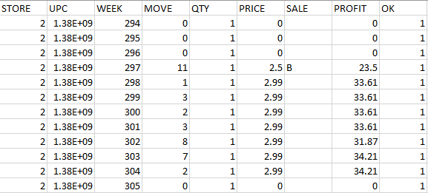

*Figure 4.2.1* Movement *file for frozen dinners*

Further we used the frozen juices movement file to find the bottom 10 products and got their details from the corresponding UPC file. The figure 4.4.2 shows these products and their corresponding profit margins in a pivot table.

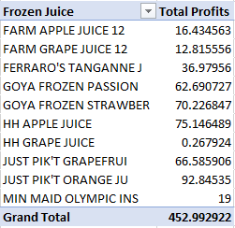

*Figure 4.2.2 Pivot* table *with total profit of least profitable frozen juices*

Figure 4.2.3 shows the bar graph for the pivot table above and we can see that the first few products reap almost no profits. We could take the bottom 5 products and can discontinue them from our stores altogether. We can use similar trend analysis to find which products do bad in every category or per store. This would help Dominick to target different products for different demographics as well.

*Figure 4.2.3 Pivot chart showing total profit frozen juices*

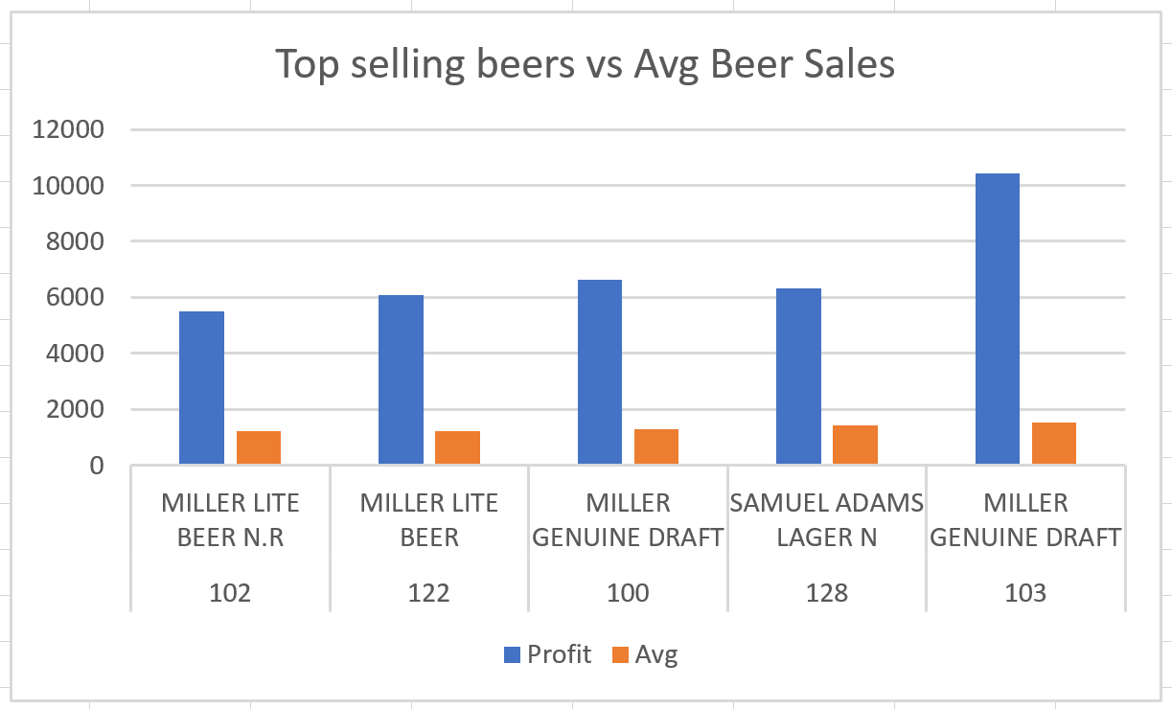

*Figure 4.1.1 Top selling beers vs* average *beer sales*

**Question 3: What strategies can we implement to make sure in-house brands sell more? How does Dominick’s in-house soda brands fare against a commercial brand like Pepsi?**

***Justification***

In-house brands reap more profits for the company since the manufacturer commission does not factor in the expenses. Analyzing the sales of Dominick’s in-house soda brands compared to a commercially popular brand like Pepsi would help the company to gauge the performance of the in-house brands and plan marketing strategies like store promotions, bundle selling and coupons to increase sales. We can expand our horizon for this analysis to include other in-house products and gauge their sales.

***Supporting Data***

To compare the sales of the Dominick’s in-house soft drinks versus a commercial brand like Pepsi. We analyzed the weekly sales of soda products currently offered by Dominick and the sales of Pepsi’s soda products. We filtered the data for the last two years as the most recent data would be a better parameter to devise the future strategies to increase the sales of in-house brand. Targeting the marketing of in-house brands would pay dividends in the long run as it would not only help in increasing the profits but also strengthening Dominick’s brand value. The movement file, WSDR and the product description file, UPCSDR were used to identify the products and their sales. Figure 4.3.1 displays the cumulative weekly sales of Pepsi and Dominick soft drinks.

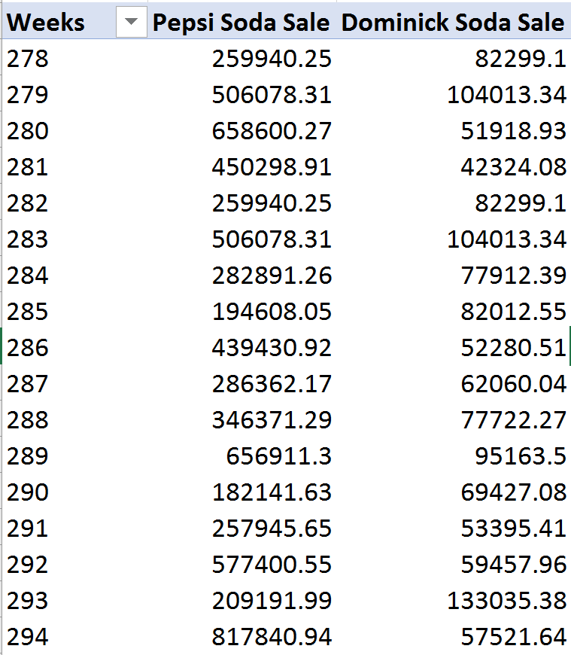

*Figure 4.3.1* Weekly *sales of Pepsi vs Dominick soft drinks.*

Figure 4.3.2 displays the gulf in sales for in-house brands using a pivot chart. This clearly demonstrates that the company needs to devise a strategy for in-house brands.

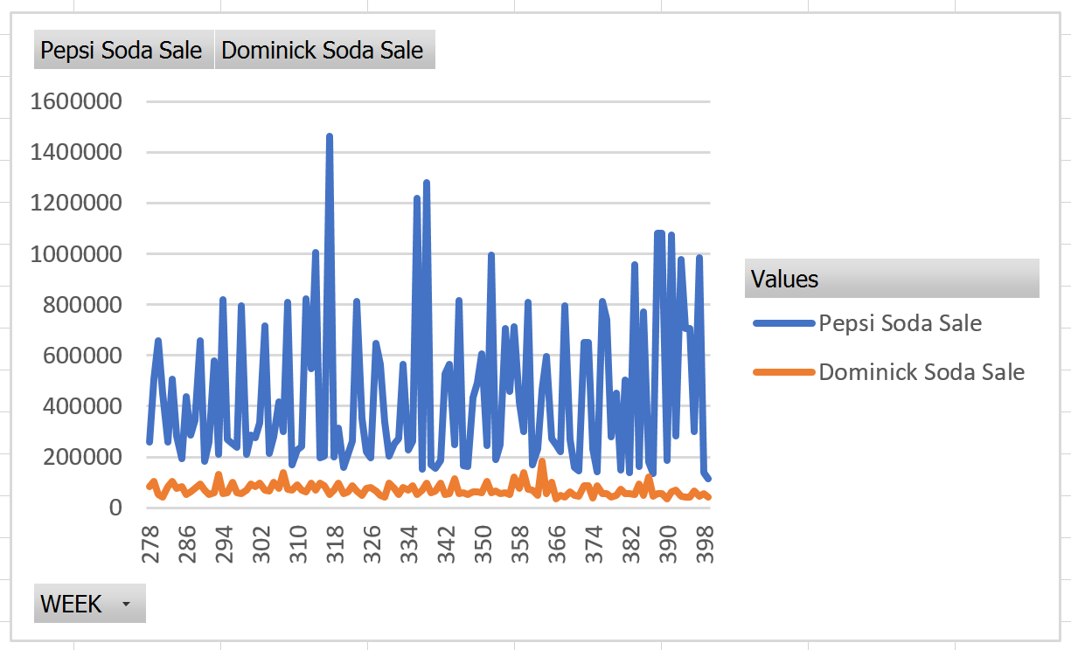

*Figure 4.3.2 Pivot chart comparing the soft drinks sales*

**Question 4: Which are the most popular snacks between cookies and crackers? Which one do we need to focus on to improve our companies position in the market?**

***Justification***

One of the most popular snacks consumed by people are cookies and crackers. But people tend to choose one over the other and that can affect the market and sales. We would aim to find which one is preferred more by the people and leverage the information to market the product accordingly and increasing the overall sales.

***Supporting data***

We can find the weekly or yearly sales data from the cookies and crackers movement table as in figure 4.4.1. We can use the price, quantity, movement and sales fields. This would help us determine which product is more popular in Dominick’s stores.

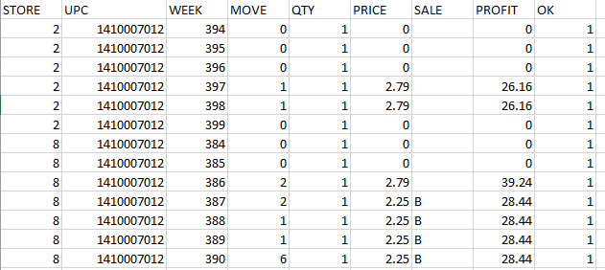

Figure 4.4.1 Movement file for cookies

We used the data to find the weekly sales of these two products. The figure 4.4.2 below has the pivot table showing this information. These details would help us analyze the trends of the sales and the profits that these two products fetch.

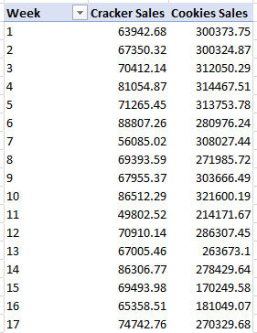

Figure 4.4.2 Pivot table with weekly sales of crackers and cookies

Figure 4.4.3 shows the line graph for the pivot table and we can easily observe that cookie sales are almost three times more than cracker sales. So, it would be a wise business decision to focus more on cookie sales to increase Dominick’s profits and have an edge over competitors.

Figure 4.4.3 Cookie and cracker sales pivot chart

**Question 5: Analyze canned soup seasonality patterns to target business strategies for peak sales seasons. Which canned soup brand is the most popular, and does its seasonality significantly affect the others?**

***Justification***

Stephen Rennard from the University of Nebraska Medical Center conducted scientific research which confirms that consuming either homemade or canned soups from supermarkets provide healing effects from sore throats or common colds (Bring on the soup, 2001). The sales of chicken noodle soup, and perhaps other soups that Dominick’s sells could reflect the seasonal peaks of illness, which occurs throughout winter months.

If soup sales follow the seasonal peaks of illness, Dominick’s could readily combat the flu season through implementing bundled discounts of popular canned soup brands. This will encourage and promote the comfort of its customers, and potentially many kids as they experience illness during “flu season”.

Additionally, the patterns of all canned soup purchases should be analyzed to see which brands or products are the most popular soups so they can be placed in an area of the store shelves that could generate additional sales revenue for Dominick’s Finer Foods. Unfortunately, we don’t have data regarding the sales of spices or vegetables which are used to make homemade soup.

***Supporting Data***

To support the conclusion that canned soup sales follow the trends of the winter flu season, we simply need to measure the aggregate sales of all the brands of canned soup. In addition, sales and movement records will be needed to see if this seasonality experienced by Campbell’s Chicken Noodle soup is experienced by other brands and soup varieties. An examination of Dominick’s store brand chicken noodle soup would also provide insight into this potential phenomenon. Figures 4.5.1 and 4.5.2 display an Excel pivot chart and table of sampled Campbell’s Chicken Noodle Soup sales between the third quarter of 1989 and the third quarter 1991. This information confirms that there is a seasonality pattern, with the first and fourth quarters having the most sales of Campbell’s Chicken Noodle Soup. However, more information is needed since other soups might not be as popular during winter months.

Figure 4.5.1 Campbell’s Chicken Soup Sales (Qtr 3. 1989 – Qtr. 3 1991)



Figure 4.5.2 Campbell’s Chicken Soup Sales (Qtr. 3 1989 – Qtr. 3 1991)

**Question 6: How does a product perform in different income areas?**

***Justification***

Demographics of a store have a high impact on the sales of a product. Studying how the stores in different income areas affect the sales of a product would help us to devise store level marketing strategies. The analysis can be presented to the marketing division of DFF for them to formulate a product promotion strategies for a particular store.

***Supporting Data***

The DEMO file contains different parameters for a store like % of hurried shoppers, average household income, etc. The WCIG files contains the sales movement of cigarettes. Analyzing the sales in relation to different demographic parameters displayed a pattern that stores with high income average sell cigarettes. Figure 4.6.1 displays the fact that as the average income of the store location increases, it leads to more sales.

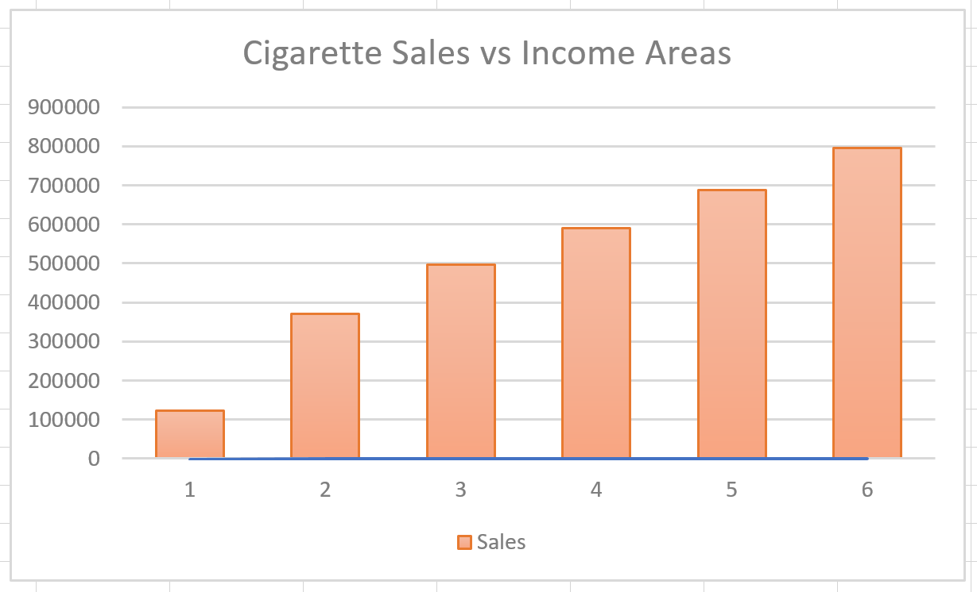

*Figure 4.6.1 Cigarette sales vs income areas*

**Question 7: Determine which demographics need to be targeted to boost pharmacy sales.**

***Justification***

Certain products sell more in certain areas compared to others. There can be various demographic factors that can affect this. If we have a knowledge of which demographic affects the sale of a particular product we can have targeted business decisions. For example, we can have targeted advertisements or promotions depending upon the different demographic factors. We compared the sales of stores with the most and least population of people over 60 years of age. The stores with more elderly customers had more analgesic sales and thus this demographic has a positive effect on the sales. We can focus on other demographics that would also have a positive effect on the pharmacy sales.

***Supporting data***

The demo.csv file as in figure 4.7.1 helped us to determine the stores that have highest and the lowest number of customers over age 60. We found that stores 103, 115, 122 sell the most analgesics and stores 113, 53 and 74 sell the least. We compared the sales of analgesics in these stores and found that the age demographic has a positive impact on the sales of analgesics. We can compare these stores amongst the different demographic factors to find which other demographic factors have a positive impact on the sales of analgesics.

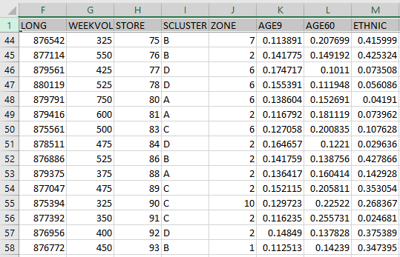

*Figure 4.7.1 Demographic file*

The figure 4.7.2 below has the pivot bar chart showing the trend in sales of analgesics in different stores. We can clearly see that age is a positive factor in affecting the sales of analgesics. We can analyze other demographics this way to find which contribute to sales the most.

*Figure 4.7.2 Pivot chart showing analgesic sales in top and bottom three stores*

**Question 8: Which products would benefit from running a promotion on them and which ones would not?**

***Justification***

The store would run promotions on products whose sales it wants to increase. Running the promotions on the right products and removing the sales from the bad ones would lead to a higher profit margin. Here we go through different products to see the trend of sales and promotions on them in the last three years. We found that the sales for frozen dinners kept decreasing even though the promotions on them were increasing over the years. It would be beneficial for Dominick to redo their promotion strategy as it is not contributing towards better sales.

***Supporting data***

We can use the ccount.csv file as in figure 4.8.1 to find out different categories of products and see which of them have a positive or a negative trend between sales and coupons.

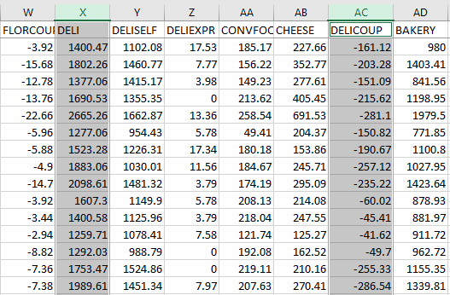

*Figure 4.8.1 Ccount file with daily sales and coupon usage of products*

We took the data from the Ccount table and used the coupons and sales columns of a particular item to find trends in them. The deli and deli coupon show a opposite trend. The yearly sum of coupons and sales for the last three years can be seen in figure 4.8.2

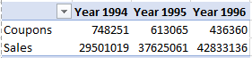

*Figure 4.8.2 Pivot table with coupon and sales of frozen dinners in last 3 years*

Figure 4.8.3 shows the line graph for the pivot table and we can clearly see the opposite trends in coupon usage and sales for deli over the past three years. This means that even though Dominick increased the coupons on deli, its sales drop. They need another strategy to increase the sales of deli as coupon is not producing the desired results. We can find similar negative or positive patterns in other products and strategize the promotion on them.

*Figure 4.8.3 Line chart with sales and coupons trend*

**Question 9: Examine various categories of canned fish, and see if there are any seasonal patterns in those specific categories as well as canned fish overall. If such trends exist, is Dominick’s raising its prices as the demand for fish rises to make a profit?**

***Justification***

Fish among other forms of seafood are typically more expensive than chicken, beef, and other meats at most grocery stores. This is because a significant amount of work is required to replenish the supply of fish. The fish must be caught from huge fishing boats with nets, and every catch of fish is not guaranteed to have the same success as the last.

Because fish is so expensive, we wish to know whether there is seasonality to various subtypes of canned fish where consumers are more likely to purchase a certain type of fish as opposed to other times of the year. Additionally, we want to know that if there is a seasonality, that Dominick’s is making the most profit from this seasonality, since fish is expensive. Insight to when certain canned fish products are selling will allow Dominick’s to exploit the customers who wish to spend a little extra on fish. Especially since these customers will be more willing to pay the extra money for fish during seasons of high demand.

***Supporting Data***

Movement data that includes the weekly sales, pricing, and profit margins for individual categories of canned fish is required. The summary information for all canned fish products can be derived from this in the completed data warehouse. Figure 4.9.1 is a pivot chart which shows the sales of Caviar, one of many categories of canned fish between September 1989 and September 1992.

Figure 4.9.1 Total Caviar Sales (1989 – 1992)

The information from this figure demonstrates that we can establish a trend for specific categories of canned fish products using the raw data we possess, as well as canned fish overall. By comparing these rising sales to price fluctuations over time, we can accurately determine if Dominick’s Finer Foods is effectively exploiting peak seasons of demand for the various canned fish categories it sells in its stores.

**Question 10: What effect does bundling of products have on the sales?**

***Justification***

Dominick Finer Foods often sells various products in bundles to lure customers to buy in bulk and save money. The reduced profit margin in this case is offset by the increased sales numbers. This analysis aims at finding the optimum bundle sizes for certain products based on previous sales numbers. The results would help us in devising a positional strategy in stores to attract more buyers.

***Supporting Data***

The UPCBER file contains the upc codes, description and the bundle it is sold in. WBER file contains the sales numbers for different beers sold by Dominick. Combining the data from the two files allowed us to get the cumulative sales for different bundles of the top selling beers. Figure 4.10.1 displays the cumulative weekly sales of Pepsi and Dominick soft drinks.

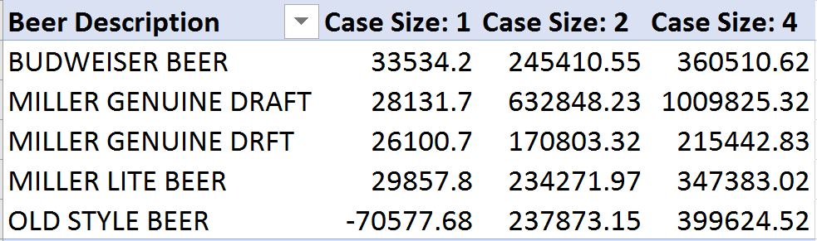

*Figure 4.10.1 Case wise sales of top selling beers*

Figure 4.10.2 displays the pivot chart highlighting increased sales of beers sold in bundles of 4.

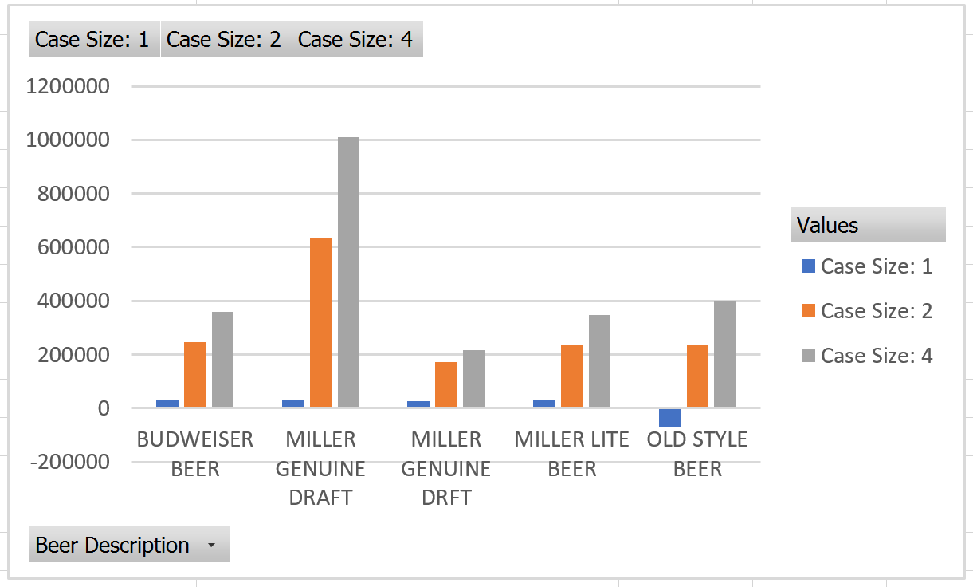

*Figure 4.10.2 Pivot chart showing the trends for different case sizes*

# 5. Build the Matrix

Our group met to discuss the questions and the various facts and dimensions we will be using to answer each of the questions. One of the biggest concerns was following Ralph Kimball’s techniques effectively. The table below illustrates the three data marts required for our project, and the dimensions necessary for answering all our business questions intersect.

|  |  |  |  |
| --- | --- | --- | --- |
|  | **Time** | **Product** | **Store Demo** |
| **Product Sales** | **X** | **X** |  |
| **Store-Specific Sales** | **X** |  | **X** |
| **Aggregate Product Sales** |  | **X** | **X** |

Figure 5.0 The Data Mart Matrix

The data mart *Product Sales* covers Dominick’s sales and profit for individual products, including their promotional attributes over time. The *Store-Specific Sales* data mart, covers the sales figures for the departments within the individual store locations over time. The final data mart, *Aggregate Product Sales* covers the store demographic and product data for the slice of time we are investigating: the last five years (January 1992 – December 1996).

# 6. Design and Justify Each Fact Table

According to Kimball, the fact tables are foundational to the functioning of the data warehouse. These tables contains vital information used to answer the business questions in decision support systems. This section details our various fact tables and provides justification for requiring these fact tables in our specific schema design.

## 6.1 FactProductSales



The table *FactProductSales* is the cornerstone of the *Product Sales* data mart. This table has the following grains: one week’s time and one individual product. In addition, this table also has the additive properties of sales (in U.S. dollars), profit (in U.S. dollars), and total units sold. The dimensions *Time* and product are needed for using this fact table, in order to answer questions II, III, and V. Those questions specifically are targeted toward product sales over time, without regard to the physical stores or their demographics. This table also accounts for the promotions for each product, with its PromoType attribute.

**6.2 FactStoreSales**

The table *FactStoreSales* is the heart of the *Store-Specific Sales* data mart. This table has the following grains: one week’s time and one individual store and its demographic attributes. In addition, this table also has the additive properties of pharmacy sales (in U.S. dollars), and pharmacy coupons (in U.S. dollars). The dimensions *Time* and *StoreDemo* are needed for this fact table, in order to answer question IV. This question involves the pharmacy department of individual stores, and therefore requires information about the total sales of their pharmacy departments, over time.

## 6.3 FactAggrProdSales

The table *FactAggrProdSales* is the foundation of the *Aggregate Product Sales* data mart. This table has the following grains: one week’s time, one individual product, one individual category, one individual store and its demographic attributes. In addition, this table also has the additive properties of aggregated sales (in U.S. dollars), and aggregated profit (in U.S. dollars). The dimensions *Product*, *ProductCategory*, and *StoreDemo* are needed for using this fact table, in order to answer question I. Furthermore, this table could provide confirmation of findings from question IV obtained through using *FactStoreSales*, since analgesics is a major pharmaceutical product category, and this fact table also uses the information in *StoreDemo.*

# 7. Design and Justify Each Dimension Table

## 7.1 DimStoreDemo

Dimensions provide structured labeling information to otherwise unordered numeric measures in the DFF database. The table *DimStoreDemo* provides information about the demographics of a store. The demographic properties enable DFF to analyze the sales of a store with respect to different demographic properties like percentage of population under age 60, percentage of unemployed population, percentage of non-white residents, etc. This dimension becomes an integral part of the *FactStoreSales* data mart and helps in analyzing the business question to find the demographics of a store which has higher pharmacy sales. DFF can target other stores with the same demographic properties to boost pharmacy sales.

## 7.2 DimTime

Time is a vital dimension because many questions answered by the data marts concern time. Without the time dimension, many of our business questions would never be answerable. Like many organizations, we use this dimension table to answer many of the key business questions. This table has a TimeID surrogate key, which is generated through the DBMS. It has the following grains: every week number, every starting date of that week, the month of the start date, quarter of the start date, and the year of the start date.

## 7.3 DimProduct

The *DimProduct* dimension table contains details about different products offered by Dominick’s Finer Foods. This is one of the most important dimension tables in our data warehouse and provides us details about any product we wish to analyze. We use this table to answer the majority of our business questions. This table has a ProdID surrogate key, generated by the database. It has the following grains: every product by UPC, the corresponding product name, the product’s brand name, Dominick’s assigned commodity code and the category of the product.

## 7.4 DimProductCategory



The *DimProductCategory* dimension table has details about the different categories of products that DFF offers. This table contains details including the auto generated CatID primary key, the category name and the category description. We get these details from the different source files available to us and the cookbook. We use this dimension table to answer Question I and to support Question IV by using category information and finding the most relevant categories to DFF’s business.

# 8. Entity-Relationship Diagrams:

Provided in this section are the entity-relationship diagrams, in relation to the overall data warehouse, and the individualized data marts. These schemas contain the fact tables presented in section 3, and the dimension tables presented in section 4. The justifications for each fact table and dimension table are presented in sections 3 and 4, respectively.

## 8.1 Overall Data Warehouse Schema



We have followed Kimball’s methodology to specify conformed dimensions, where multiple fact tables share common dimensional tables. Conformed dimensions are common, standardized, dimensions that are managed once in the extract, transformation, and load (ETL) system and then reused by multiple fact tables. Conformed dimensions deliver consistent attributes across dimensional models. The overall data warehouse combines the three data marts that we have designed to answer the business questions for DFF. As shown in the image above, the store demographic dimension table is shared between store sales and product sales fact tables. The information in product dimension is utilized by product sales and product aggregate sales fact tables. Similarly, the time dimension is shared by the product sales and store sales fact tables. Data warehouse ends up being segmented into several logically self-contained and consistent data marts, rather than a big and complex centralized model.

## 8.2 Product Sales Data Mart



The Product Sales data mart caters to sales information available for Dominick. The product sales information, like the product codes, total sales and profits are available with respect to time and product dimensions. This data mart enables us to answer question 3, 5 and 1 for DFF.

## 8.3 Store-Specific Sales Data Mart

## 

We use aggregated sales data, split over store-wise demographic information and different time dimensions to design this data mart. This data mart would allow us to answer question 7 for Dominick Finer Foods.

## 8.4 Aggregate Product Sales Data Mart



The Aggregate Product Sales data mart presents an aggregated view of the yearly product sales for DFF. We have utilized the additive property of the sales in the movement files to come up with the fact table in the data mart. This data mart helps business to analyze different category sales and then strategize to boost the sales of that category. This data mart answers question 1, and could provide supporting information for question 7.

# 9. ETL Plan

ETL refers to the Extract, Transform and Load process in data warehousing. They aim at extracting the data from source files, preparing them in the staging area so that they can be loaded into the data warehouse. The ETL process can be briefly explained as:

Extract - Extract data from homogeneous or heterogeneous data sources.

Transform - Transform the data for storing it in proper format or structure for querying and analysis purpose.

Load - Load it into the final target (database, more specifically, operational data store, data mart, or data warehouse).

The steps we took for building Dominick’s data warehouse are displayed in the figure 1 and explained in detail in the following sub-sections.

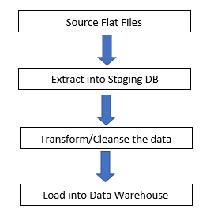

Figure 1. ETL plan steps

## 9.1 Source Data Files

We will utilize the flat files available online at Dominic Finer Food’s Marketing database (<https://edit.chicagobooth.edu/research/kilts/marketing-databases/dominicks>). The flat files are broadly divided into general files and category files. The general files consist of Customer Count Files and Store-Specific Demographic files.

### 9.1.1 Customer Count Files:

The customer count file includes information about in-store traffic. The data is store specific and daily. The customer count data refers to the number of customers visiting the store and purchasing something. Also in the customer count file is a total dollar sales and total coupons redeemed figure, by DFF defined department.

### 9.1.2 Store Specific Demographics:

The demographics file consists of store-specific demographic data. The data originally comes from U.S. government (1990) census data for the Chicago metropolitan area. Market Metrics processed this data to generate demographic profiles for each of the DFF stores. The table below gives the descriptions for all the files in the demographics database. Category files can be downloaded by UPC or movement.

### 9.1.3 UPC files:

These contain a description of each UPC in a category. The files are named upcxxx, where xxx is the three-letter acronym for the category.

### 9.1.4 Movement files:

These contain sales information at the store level for each upc in a category. The information is stored on a weekly basis. The files are named wxxx where xxx is the three-letter acronym for the category.

### 9.2 Extract into Staging Database:

The Extract step covers the data extraction from the source .csv files and makes this data accessible for further processing. The main objective of the extract step is to retrieve all the required data from these files with only the minimum resources required to ensure processing efficiency. The extract step will be designed in a manner so as to not affect the source system in terms or performance, response time or any kind of locking.

We would extract the flat files into the staging database using SSIS. We plan to use different approaches for extracting the previously mentioned types of flat source files. The Customer Count and Store Specific Demographic files would be extracted and stored in ccount_temp and demo_temp tables respectively.

The UPC and Movement files are multiple product category files. UPC and Movement files will each have one SSIS package each to perform the extraction. This prevents the necessity to create multiple SSIS packages for every respective Movement or UPC .csv flat file. These SSIS packages will extract the information simultaneously to upc_temp and movement_temp tables, without needing to create multiple SSIS packages for the extraction.

### 9.3 Transform and Cleanse the Data

After the data has been extracted from the source files and is loaded in the staging area, we continue to clean and transform the data according to our own needs. The transform step makes sure that the data is available in a proper format and structure so that is ready to be loaded into the data warehouse from the staging area where we can run queries on it. We apply certain data transformation rules and create conformed dimensions, so that data across different tables can be merged easily, generate aggregates and create keys and dependencies. The main steps that we focus on in the transform phase are cleaning, filtering, enriching, splitting and joining. Cleaning focuses on removing bad data that can give erroneous results, so as to improve the quality of data available for analysis. In filtering, we select only those columns that we need for our analysis and ignore the rest of them. We then enrich the data by dividing it into more usable and understandable columns. We can also split or merge the columns to make more meaningful columns in our destination tables. Then we join the data from multiple sources to create our data marts.

The cleanse and transform rules that we will apply to our data to make it ready for loading into the data warehouse are as follows:

* From the CCOUNT table we only select *pharmacy* and *pharcoup* column as we only need them for our analysis
* From the demographic table we take *store, city, zip, Income, Age9, Age60, Single, Unemp, Retired, Nwhite* columns and ignore the rest
* From the UPC table we will take the *upc, description* and *com_code*. We will divide the upc to find the brand code
* From the various movement tables, we take *upc, sale, move, qty* and *price*. We will create sales and profit derived columns from these selected columns
* Get rid of the columns with bad data like dots or random nulls in any of the files
* In all of the files, only select the data that corresponds to store numbers between 2 and 139, as they are the only valid stores according to the codebook
* Delete the rows from UPC and movement tables, with UPC length not in the range of 9 to 11 numbers.
* Only consider the rows with the OK flag set as 1 on the movement files, as other rows are not trustworthy and cannot be used for analysis.
* The date range across all tables should be between week 121 and 381, including both
* We conform the data and types across all the tables. For example, set the UPC code to varchar, the sale and profit to real etc.
* We will aggregate the sales across all the available data by stores, so we can draw store-wise conclusions
* We will aggregate sales by week and UPC for the Product Sales data mart.
* We will create sales and profit derived columns for the movement data, so we can run analysis on sales and profit of all the products we accepted.
* We will remove trial size and discontinued products from the UPC data since this information is unreliable.

### 9.4 Load into data warehouse:

After all the data is cleaned and transformed in the data staging area, it is ready to be loaded into the data warehouse. In the loading process we used lookups, aggregation, data conversion and SQL tasks to load the data in Dominick’s warehouse. We prepare the necessary dimension tables and fact tables to answer the key business questions. The mapping table that maps all the data in the staging area to the data warehouse is as follows:





**10. ETL Implementation**

Our group began by creating two database schemas on the *infod**ata.tamu.edu* SQL Server: *602group13-staging* and an empty data warehouse area, *602group13-dw*.

We used SQL Server Integration Services (SSIS) to implement the ETL process for creating our data warehouse from the various source files.

**10.1 ETL for Customer Count data**

**Data Extraction:**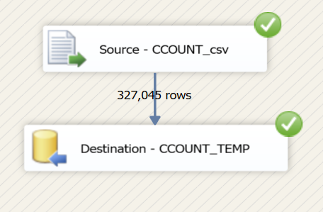

We extracted data from ccount.csv flat file using SSIS Import/Export wizard and loaded the data in a table called *ccount_temp*. We retained the data types and the original volume of data in the temp table and performed the cleansing and transformation on this table. Figure 10.1.1 shows the data flow task for the extraction.

*Figure 10.1.1 Data Flow Task for ccount extraction*

**Data Cleansing and Transformation:**

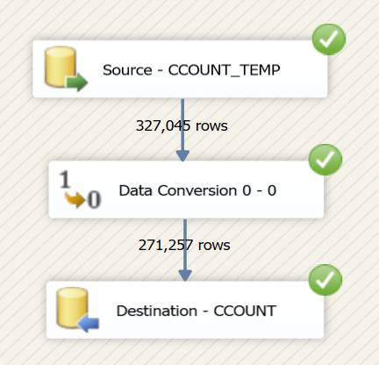Post extraction of customer count data into ccount_temp table in the staging database, we then cleansed the data to remove bad rows and transformed it to meet the requirements of our business questions. We fixed the data types of the columns with the help of data conversion transformation in SSIS. We converted the store and week columns to unsigned integers and that took care of the bad data in the columns as we discarded the failed rows. We developed this incrementally by testing the package on a subset of bad and useful data and then running the package on the complete *ccount_temp* table to ensure integrity of data. Figure 10.1.2 demonstrates the successful package execution.

*Figure 10.1.2 Data Flow Task for transformation*

Figure 10.1.3 below shows control flow task. Upon completion of the load to ccount table, we clean the data in the table to first remove the garbage stores as per Dominic’s manual and cookbook and then the weeks to support our analysis. We have included weeks from 121 to 381, both included as we are analyzing the data for the past five years to develop future strategy.

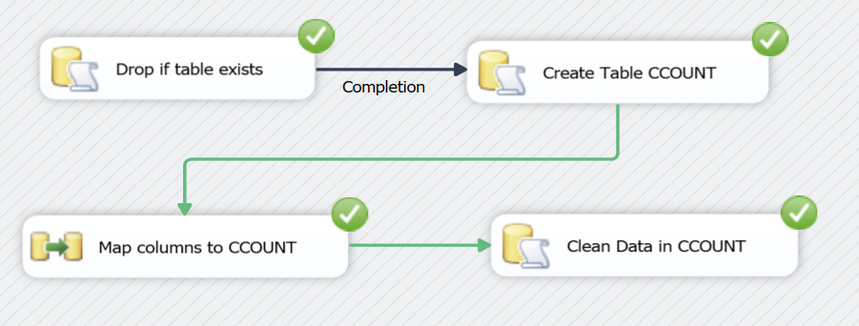

*Figure 10.1.3 Control Flow Task for transformation*

The SQL Query used for cleaning the data is shown in Figure 10.1.4

|  |
| --- |
| DELETE FROM CCOUNT  WHERE (STORE < 2 OR STORE > 139  OR WEEK < 121 OR WEEK > 381); |

*Figure 10.1.4: SQL Query to clean CCOUNT*

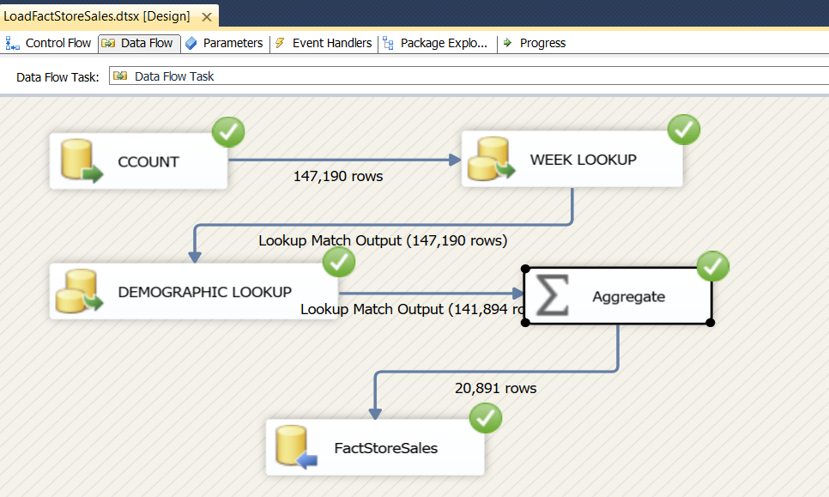**Data Load to Warehouse:**

*Figure 10.1.4 Data Flow Task for Fact Table Load*

After transforming and cleansing the data in the CCOUNT table, we load the data into the FactStoreSales data to create the star schema. The fact table consists of two foreign keys TimeID and DemoID. We refer these keys from the dimension tables, DimTime and DimStoreDemo via the use of two lookups as shown below in Figure 10.1.4. The unmatched rows are discarded and not loaded into the fact tables to maintain referential integrity among the tables. After fetching the foreign keys, we aggregate the store-wise data weekly to obtain the final fact table.

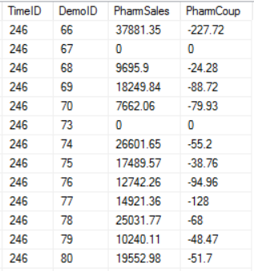Figure 10.1.5 below shows the unaggregated data in Ccount table and the aggregated data in the FactStoreSales table post the data load.

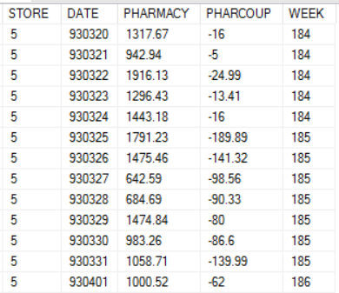

*Ccount Table FactStoreSales*

*Figure 10.1.5 Pre-load and Post-load Customer Count table*

**10.2 ETL for Demographics Data**

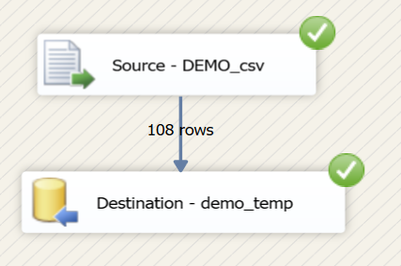**Data Extraction:**

We extracted data from demo.csv flat file using SSIS Import/Export wizard and loaded the data in a table called *demo_temp*. We retained the data types and the original volume of data in the temp table and performed the cleansing and transformation on this table. Figure 10.2.1 shows the data flow task for the extraction.

*Figure 10.2.1 Data Flow Task for demo extraction*

**Data Cleansing and Transformation:**

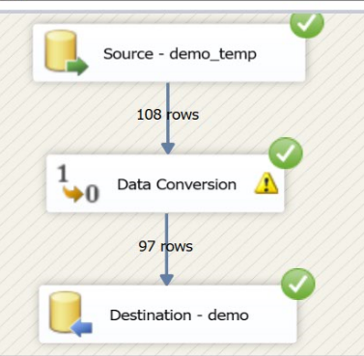Post extraction of demographics data into demo_temp table in the staging database, we cleansed the data to remove bad rows and transformed it to meet the requirements of our business questions. We fixed the data types of the columns with the help of data conversion transformation in SSIS. We converted the store and zip columns to unsigned integers and that took care of the bad data in the columns as we discarded the failed rows. We developed this incrementally by testing the package on a subset of bad and useful data and then running the package on the complete *demo_temp* table to ensure integrity of data. Figure 10.2.2 demonstrates the successful package execution. We remove the extra columns from the demo table and just retain the ones required for our analysis.

*Figure 10.2.2 Data Flow Task for transformation*

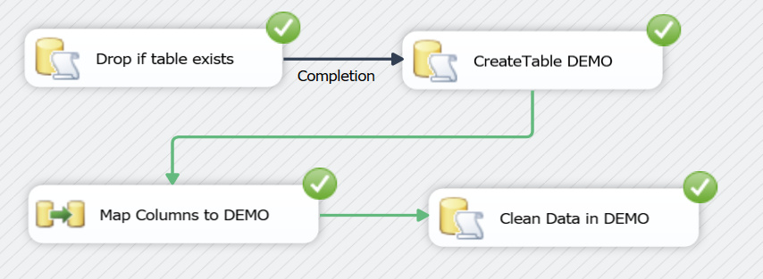Figure 10.2.3 below shows control flow task. Upon completion of the load to demo table, we clean the data in the table to remove the garbage stores as per Dominic’s manual and cookbook. The valid stores are from 2 to 139, and the raining ones are deleted.

*Figure 10.2.3 Control Flow Task for transformation*

The SQL Query used for cleaning the data is shown in Figure 10.2.4

|  |
| --- |
| DELETE FROM DEMO  WHERE STORE < 2 OR STORE > 139; |

*Figure 10.2.4: SQL Query to clean DEMO*

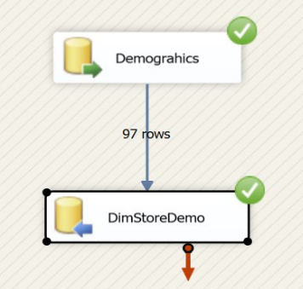 **Data Load to Warehouse:**

After transforming and cleansing the data in the DEMO table, we load the data into the DimStoreDemo dimension table to create the star schema. The dimension table includes a primary key column which has been included in the Source OLE DB connection as shown below in Figure 10.1.4. The package extracts a row from the demo table in staging schema, adds a primary key generated by ROW_NUMBER () function and then inserts it into the dimension table in the warehouse schema.

*Figure 10.2.4 Data Flow Task for Dimension Load*

The query in the source OLE DB connection is shown below in the Figure 10.2.5.

|  |
| --- |
| SELECT  ROW_NUMBER() OVER(ORDER BY [STORE] ASC) AS [StoreDemoID],  [STORE] AS [StoreNum],  [CITY] AS [City],  [ZIP] AS [Zip],  [INCOME] AS [Income],  [AGE9] AS [PerUnder9Yrs],  [AGE60] AS [PerOver60Yrs],  [SINGLE] AS [PerSingle],  [UNEMP] AS [PerUnemployed],  [RETIRED] AS [PerRetired],  [NWHITE] AS [PerNonWhite]  FROM [dbo].[demo]; |

*Figure 10.2.4 Data Flow Task for Dimension Load*

Figure 10.2.5 below shows the transformed and cleansed data in Demo table and then the DimStoreDemo dimension table post the data load.

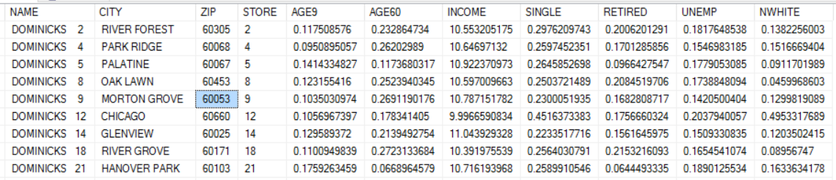

Demo Table

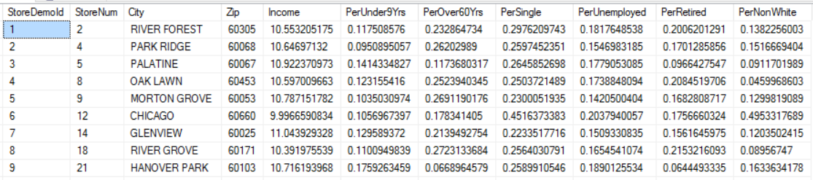

DimStoreDemo Dimension Table

*Figure 10.2.5 Pre-load and Post-load Demographics table*

**10.3 ETL for Products Data**

The extraction and transformation of the UPC data CSV files, ran in a for each loop which handled both the extraction, and transformation portions of the process. Figure 10.3.1 below depicts the UPC Transfer for each loop which was used for all upcxxx .csv files simultaneously.

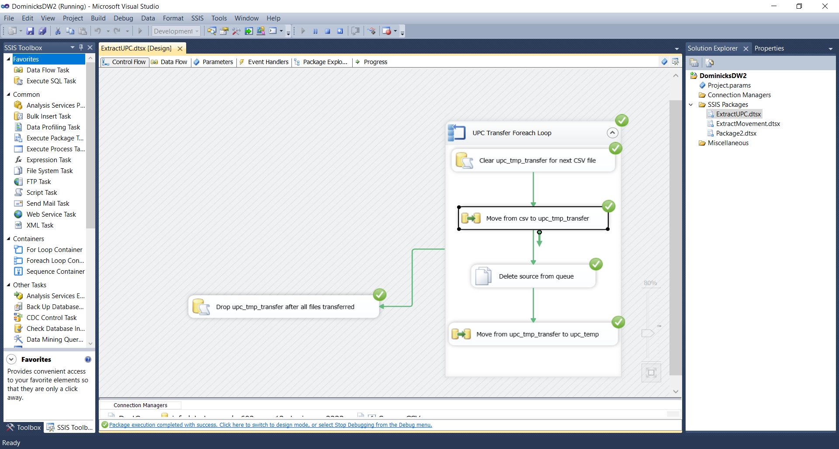

*Figure 10.3.1: UPC Control Flow*

The first SQL action, depicted in Fig. 10.3.2 truncated *upc_tmp_transfer* so the next CSV file could be processed.

|  |
| --- |
| DROP TABLE [upc_tmp_transfer];  CREATE TABLE [upc_tmp_transfer] ([COM_CODE] float, [UPC] varchar(12), [DESCRIP] varchar(50)); |

*Figure 10.3.2: SQL Query to truncate upc_tmp_transfer*

After that query successfully completed, the “Move from csv to upc_tmp_transfer” data flow executed. This data flow is depicted in Fig. 10.3.3. The source CSV file was loaded from the file system and read. Then, the UPC numbers were checked to ensure that they met the correct filtering criterion. The numbers and characters in the UPC then were converted and stored into the *upc_tmp_transfer* table. Fig. 10.3.4 displays an example *upc_tmp_transfer* table upon the successful processing of the data flow in Fig 10.3.3 during one iteration.

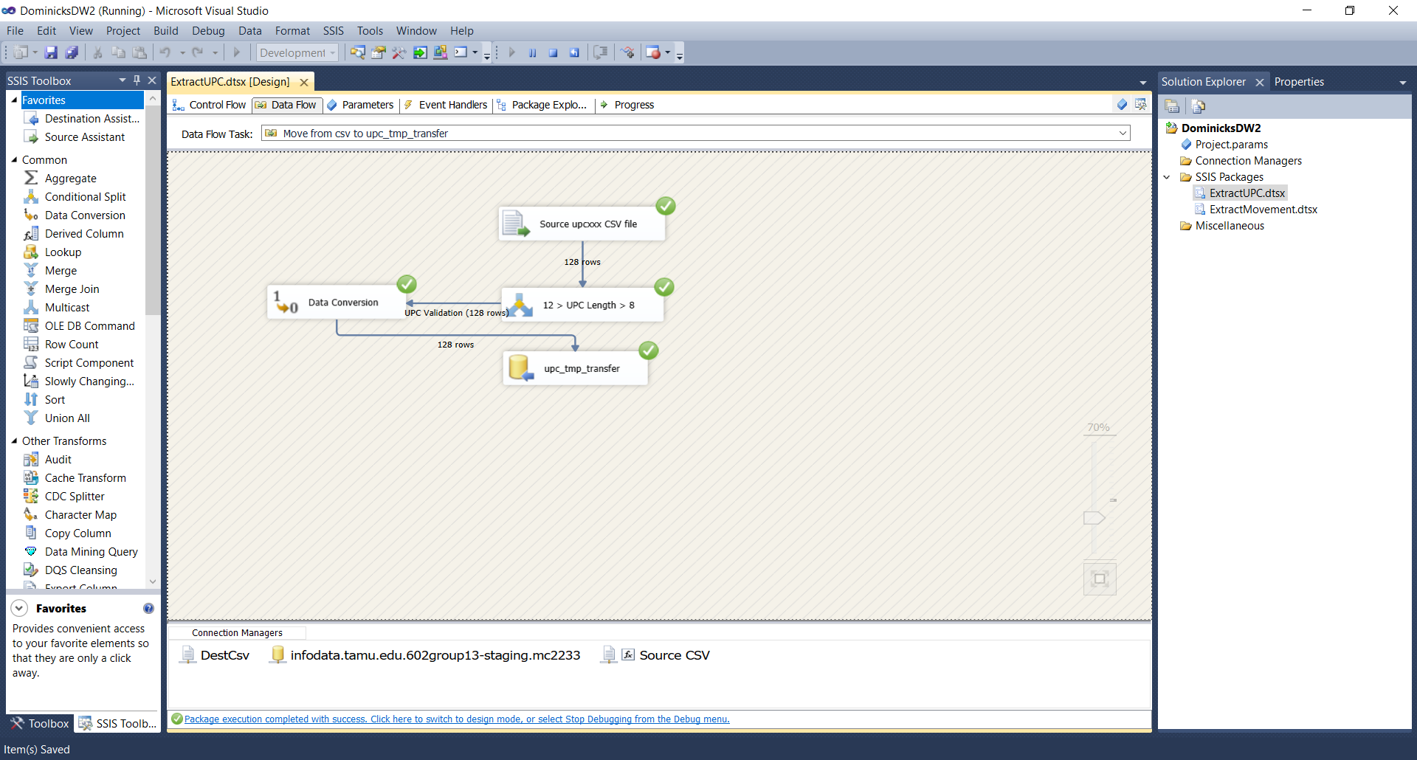

*Figure 10.3.3: Data flow “Move from CSV to upc_temp_transfer”*

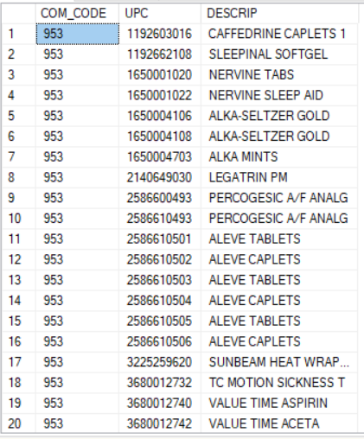

*Figure 10.3.4: upc_tmp_transfer after the extraction of UPCANA.csv in the first data flow.*

Following the extraction into *upc_tmp_transfer*, the “Move from upc_tmp_transfer to upc_temp” (Fig. 10.3.5) data flow was executed. The three character category code was added by using a prepared SQL query variable within SSIS to ensure that the product category code from the source file was added when the rows were added to *upc_temp*. Fig. 10.3.6 displays that SQL expression, which also cleansed discontinued products and also unneeded symbols from the product descriptions.

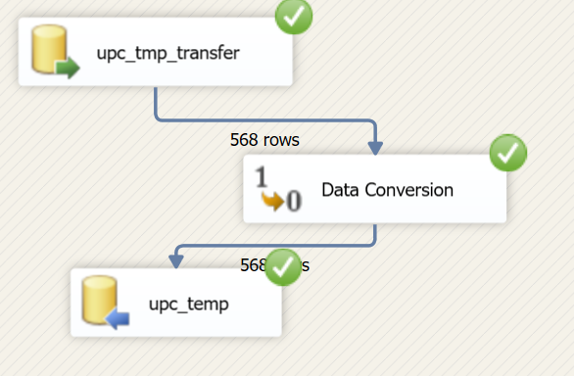

*Figure 10.3.5: Data flow “Move from upc_tmp_transfer to upc_temp”*

|  |
| --- |
| SELECT [COM_CODE],REPLACE(REPLACE(REPLACE([DESCRIP],'#',''),'*',''),'$','') AS [DESCRIP],[UPC], REPLACE('"+ @[User::SourceFileName] +"','UPC','') AS [ProdCatCode] FROM [602group13-staging].[dbo].[upc_tmp_transfer] WHERE [DESCRIP] NOT LIKE '~%'; |

*Figure 10.3.6: This SQL Query is used to further cleanse and move data from upc_tmp_transfer to upc_temp.*

Upon completion of an iteration of this for each loop, the process starts over, with the *upc_tmp_transfer* table being emptied, to prevent data duplication. The final result of *upc_temp*, after all the flat UPC files were processed is displayed in Fig. 10.3.7.

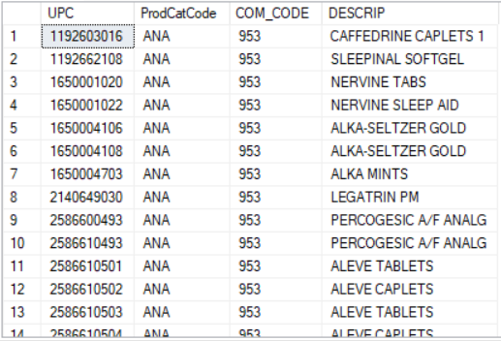

*Figure 10.3.7 – upc_temp after the UPC for each Loop finished all files.*

We then created a second SSIS package for performing final transformations and the loading of the data into the data warehouse area. The single data flow for this second process is depicted in Fig. 10.3.8.

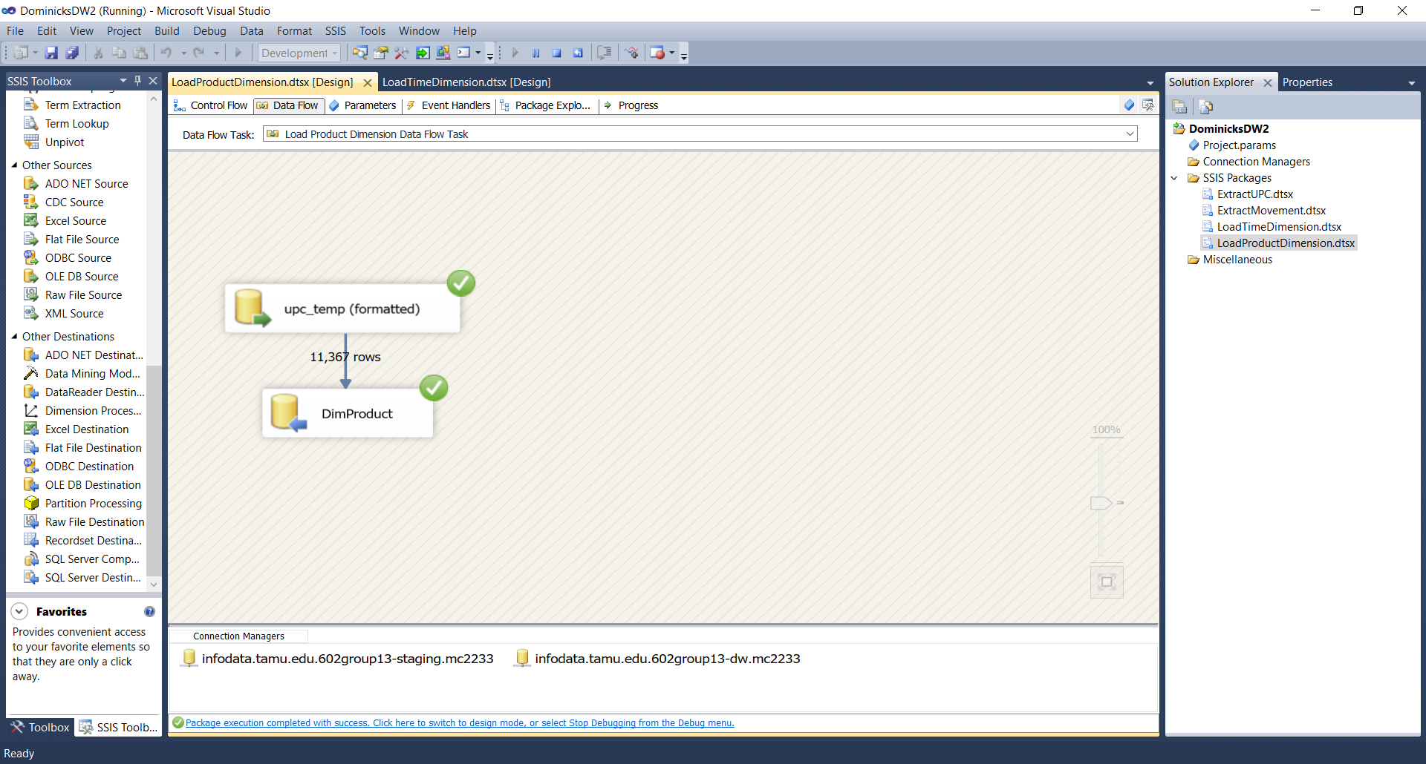

*Figure 10.3.8: Data Flow for upc_temp to DimProduct*

The data flow in Fig. 10.3.8 uses the SQL query in Fig. 10.3.9 as its data source. This allows for the final transformations which include key generation, and extracting the manufacturer’s identifier from the UPC.

|  |
| --- |
| SELECT row_number() OVER(ORDER BY [UPC] asc) AS ProdID, [UPC],[DESCRIP] AS [ProdName], REPLACE([UPC],RIGHT([UPC],5),'') AS BrandCode,[COM_CODE] as [ComCode], [ProdCatCode] FROM dbo.[upc_temp]; |

*Figure 10.3.9: This SQL Query is used to add a key and format the rows according to the prescribed format for the DimProduct table.*

The final result of the ETL process for DimProduct is displayed in Fig. 10.3.10

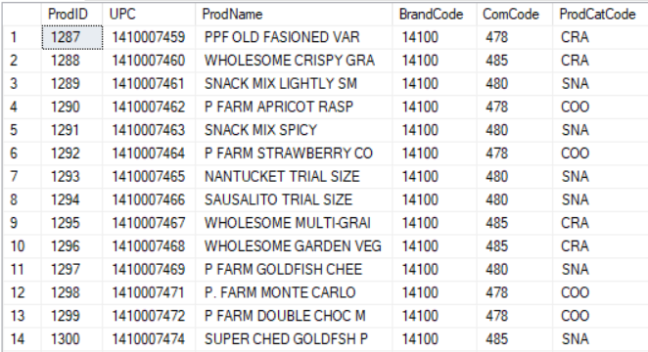

*Figure 10.3.10: The final DimProduct table.*

**10.4 ETL for Movement data**

The extraction and transformation for the Movement .csv files, ran in a for each loop that covered both the extraction and transformation tasks. Fig. 10.4.1 depicts the “Movement Transfer Foreach Loop” which was used for all wxxx.csv files simultaneously.

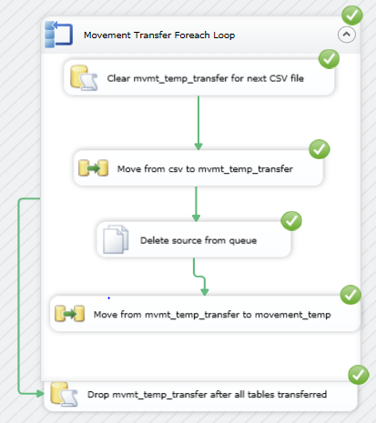

*Figure 10.4.1 Movement Control Flow*

The first SQL action, depicted in Fig. 10.4.2 truncated *mvmt_temp_transfer* so the next CSV file could be processed. This would run at the beginning of the next iteration.

|  |
| --- |
| DROP TABLE [mvmt_temp_transfer];  CREATE TABLE [mvmt_temp_transfer] ([StoreNum] bigint,[WkNum] bigint,[UPC] varchar(12),[Sales] real,[PromoType] varchar(1),[Profit] real,[UnitsSold] real); |

*Figure 10.4.2: SQL to “Clear mvmt_temp_transfer for next CSV file”.*

After that query successfully completed, the “Move from csv to mvmt_temp_transfer” data flow executed. This data flow is depicted in Fig. 10.4.3. The source CSV file was loaded from the file system and read. Then, the rows were checked to ensure that the OK value was equal to 1, then the data types for each number was corrected to ensure that they were in integer format. The numerical check ensured that each row had the values we were seeking. The script never processed any records that did not have valid entries for our StoreNum, WkNum, and sales filters. Finally, the calculations for profit in dollars, and sales in dollars were performed. If the profit was 0, it went through another calculation filter to ensure that no division by zero occurred. Finally, the data was put into the *mvmt_temp_transfer* table. Fig. 10.4.4 displays an example *mvmt_temp_transfer* table upon the successful processing of the data flow in Fig 10.4.3 during one iteration.

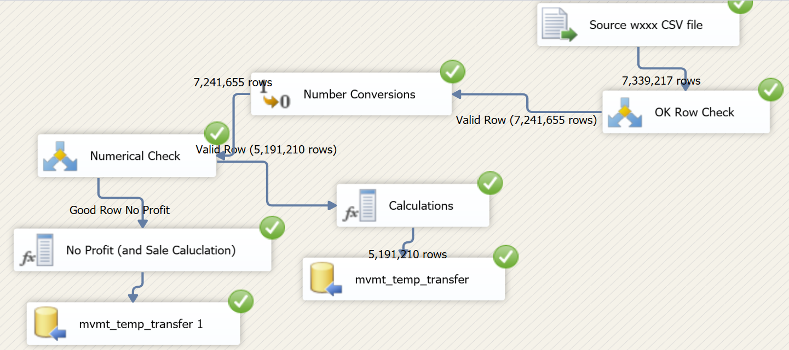

*Figure 10.4.3: “Move from csv to mvmt_temp_transfer” Data Flow*

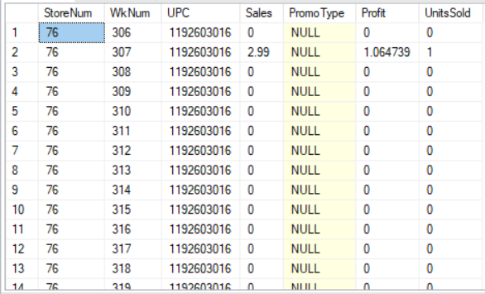

*Figure 10.4.4: mvmt_temp_transfer after the extraction of WANA.csv in the first data flow.*

Following the extraction into *mvmt_temp_transfer*, the “Move from mvmt_temp_transfer to movement_temp” (Fig. 10.4.5) data flow was executed. The three character category code was added by using a prepared SQL query variable within SSIS to ensure that the product category code from the source file is added when the rows were added to *movement_temp*. Fig. 10.4.6 displays that SQL expression.

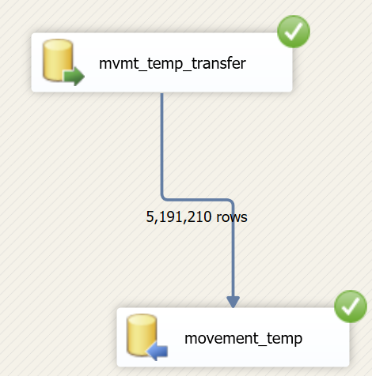

*Figure 10.3.5: Data flow “Move from mvmt_temp_transfer to movement_temp”*

|  |
| --- |
| SELECT [StoreNum],[WkNum],[UPC],[Sales],[PromoType],[Profit],[UnitsSold],'"+ @[User::ProductCatCode] +"' AS [ProdCatCode] FROM [602group13-staging].[dbo].[mvmt_temp_transfer]; |

*Figure 10.3.6: This SQL Query is used to add the product category to the data before transferring to movement_temp.*

Upon completion of an iteration of this for each loop, the process starts over, with the *mvmt_temp_transfer* table being emptied, to prevent data duplication. The final result of *movement_temp*, after all the flat movement files were processed is displayed in Fig. 10.4.7.

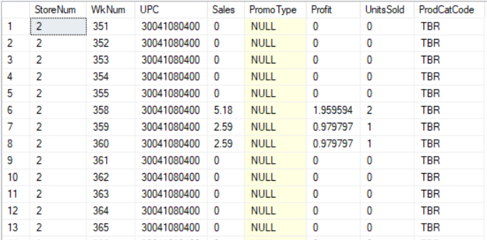

*Figure 10.4.7: movement_temp after the Movement for each loop finished all files*

We then created two more SSIS packages for loading of the data into the data warehouse area into *FactProductSales* (10.4.8) and *FactAggrProductSales* (10.4.9).

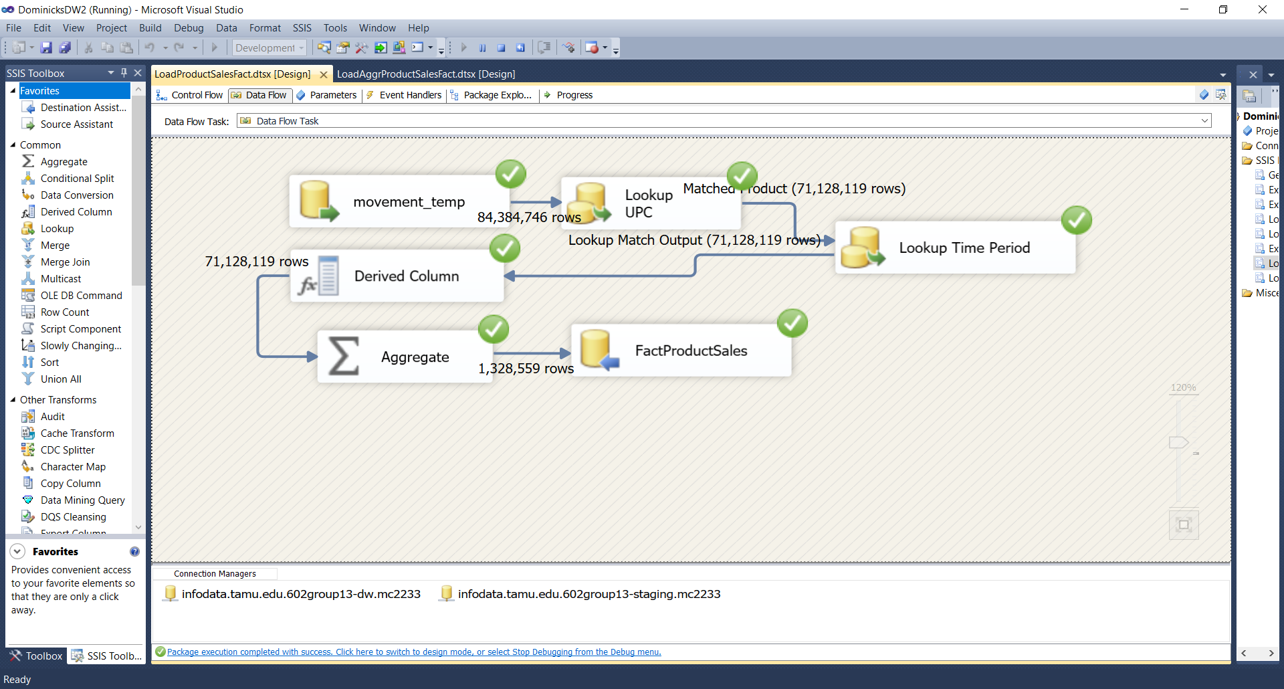

*Figure 10.4.8: movement_temp to FactProductSales data flow.*

The data flow in Fig. 10.4.8 directly connects to the *movement_temp* table, and then, using the UPC, it looks up the product ID from DimProduct. Then the week number is converted into TimeID through a lookup against the DimTime table. A PromoType of N is added in the derived column field to the items that do not have promotions during a certain week. The granularity of this fact table is by week and product. This data flow performs an aggregation to total the numerical fields and inserts the rows into FactProductSales in the data warehouse area. Figure 10.4.9 depicts the completed FactProductSales table in the data warehouse.



*Figure 10.4.9: Completed FactProductSales table.*

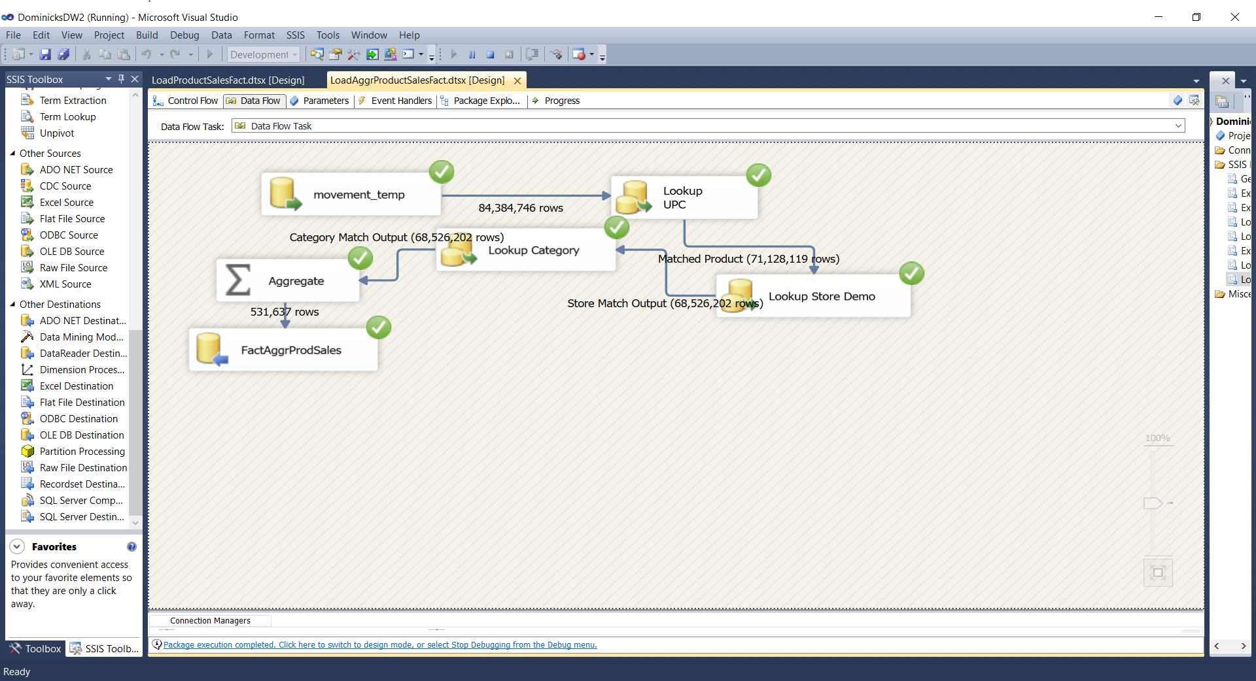

*Figure 10.4.10: movement_temp to FactAggrProdSales data flow*

The data flow in Fig. 10.4.9 directly connects to the *movement_temp* table, and then, using the UPC, it looks up the product ID from DimProduct. Dominick’s Store number is converted into the data warehouse’s identifier through a lookup against the DimStoreDemo table. The product’s category is then retrieved from a lookup against DimProductCategory. The granularity of this fact table is by store, category, and product. This data flow performs an aggregation to total the numerical fields, and inserts the rows into FactProductSales in the data warehouse area. Figure 10.4.10 depicts the completed FactProductSales table in the data warehouse.

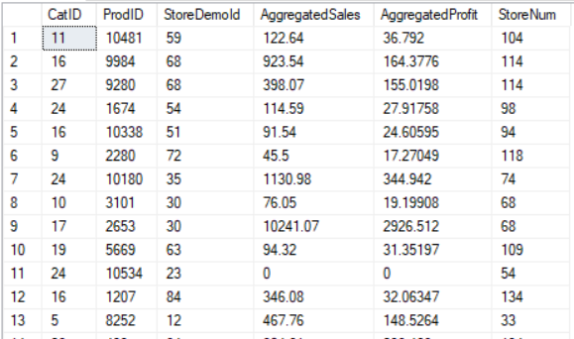

*Figure 10.4.10: Completed FactAggrProductSales table.*

**10.5 ETL for Time**

The following SQL statement (Figure 10.5.1) was executed as a data source in the SSIS data flow depicted in Figure 10.5.2 to load the time dimension. The statement creates rows for each week iteratively for the conversion of store weeks to TimeID, and also the conversion of the starting day of the week to the week number.

|  |
| --- |
| DECLARE @StartDate DATE = '19920102', @EndDate DATE = '19970101';  WITH datemgr AS (SELECT DATEADD(DAY,DATEDIFF(DAY,0,@StartDate),0) AS WkStartDate UNION ALL  SELECT DATEADD(DAY,7,WkStartDate) FROM datemgr WHERE DATEADD(DAY,7,WkStartDate) <= @EndDate  ) SELECT row_number() over (order by dm.WkStartDate asc) as TimeID, row_number() over (order by dm.WkStartDate asc) + 120 as WkNum, WkStartDate,  DATENAME(MONTH,WkStartDate) As [Month],  DATEPART(QUARTER,WkStartDate) AS [Qtr],  DATEPART(YEAR,WkStartDate) AS [Year]  FROM datemgr dm  OPTION (MAXRECURSION 0) |

*Figure 10.5.1: Load DimTime SQL statement.*

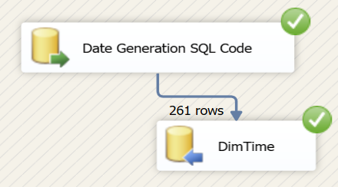

*Figure 10.5.2: Load DimTime data flow.*

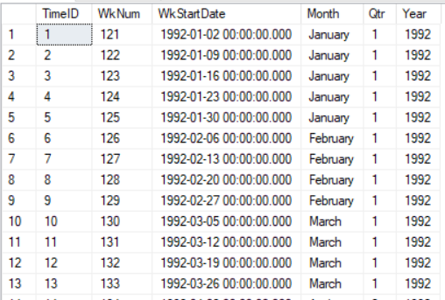

*Figure 10.5.3: DimTime after loading.*

**10.6 ETL for Product Categories**

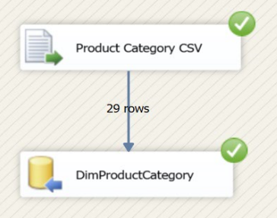DFF’s database has products and movement data segregated by distinct categories. One of our data marts required the category data. We referenced DFF’s manual and cookbook to create a csv using an sql query to generate product category name and description. The flat file was then extracted into the warehouse schema to create the DimProductCategory dimension table. The table has three columns: data less primary key for CatID, CadtegoryName and CategoryDesc. Figure 10.6.1 shows the successful package run for the import.

*Figure 10.6.1: DimProductCategory Dimension table*

Figure 10.6.2 shows the sql query used to generate the category names and descriptions.

|  |
| --- |
| SELECT 'ANA' AS CategoryName, 'Analgesics' AS CategoryDesc  UNION  SELECT 'BAT' AS CategoryName, 'Bath Soap' AS CategoryDesc  UNION  SELECT 'BER' AS CategoryName, 'Beer' AS CategoryDesc  UNION  SELECT 'BJC' AS CategoryName, 'Bottled Juice' AS CategoryDesc  UNION  SELECT 'CSO' AS CategoryName, 'Canned Soup' AS CategoryDesc  UNION  SELECT 'TNA' AS CategoryName, 'Canned Tuna' AS CategoryDesc  UNION  SELECT 'CER' AS CategoryName, 'Cereals' AS CategoryDesc  UNION  SELECT 'CIG' AS CategoryName, 'Cigarettes' AS CategoryDesc  UNION  SELECT 'CHE' AS CategoryName, 'Cheese' AS CategoryDesc  UNION  SELECT 'COO' AS CategoryName, 'Cookies' AS CategoryDesc  UNION  SELECT 'CRA' AS CategoryName, 'Crackers' AS CategoryDesc  UNION  SELECT 'DID' AS CategoryName, 'Dish Detergent' AS CategoryDesc  UNION  SELECT 'FSF' AS CategoryName, 'Fabric Softener' AS CategoryDesc  UNION  SELECT 'FEC' AS CategoryName, 'Front-End-Candies' AS CategoryDesc  UNION  SELECT 'FRD' AS CategoryName, 'Frozen Dinners' AS CategoryDesc  UNION  SELECT 'FRE' AS CategoryName, 'Frozen Entrees' AS CategoryDesc  UNION  SELECT 'FRJ' AS CategoryName, 'Frozen Juices' AS CategoryDesc  UNION  SELECT 'GRO' AS CategoryName, 'Grooming Products' AS CategoryDesc  UNION  SELECT 'LND' AS CategoryName, 'Laundry Detergents' AS CategoryDesc  UNION  SELECT 'OAT' AS CategoryName, 'Oatmeal' AS CategoryDesc  UNION  SELECT 'PTW' AS CategoryName, 'Paper Towels' AS CategoryDesc  UNION  SELECT 'RFJ' AS CategoryName, 'Refrigerated Juices' AS CategoryDesc  UNION  SELECT 'SOA' AS CategoryName, 'Soap' AS CategoryDesc  UNION  SELECT 'SDR' AS CategoryName, 'Soft Drinks' AS CategoryDesc  UNION  SELECT 'SHA' AS CategoryName, 'Shampoos' AS CategoryDesc  UNION  SELECT 'SNA' AS CategoryName, 'Snack Crackers' AS CategoryDesc  UNION  SELECT 'TBR' AS CategoryName, 'Toothbrushes' AS CategoryDesc  UNION  SELECT 'TPA' AS CategoryName, 'Toothpastes' AS CategoryDesc  UNION  SELECT 'TTI' AS CategoryName, 'Toilet Papers' AS CategoryDesc |

*Figure 10.6.2: SQL Query to generate Product Category and Descriptions*

Figure 10.6.3 shows a snippet of the data in the DimProductCategory Dimension table.

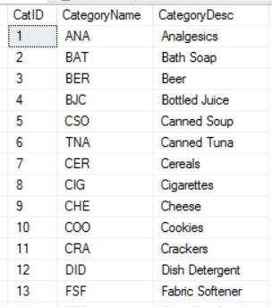

*Figure 10.6.3: DimProductCategory after loading*

**11. BI Reporting**

**11.1 Reporting Plan**

### 11.1.1 Question 1

To answer the question “Which products do we promote in our highest grossing stores?”, we first select the top three grossing stores and then analyze the top selling products in those stores. The marketing team can see the trends of top products vs top stores and decide on which product marketing strategy. We chose SSRS to generate the report for the question as it allows reporting in multiple delivery methods and formats and it provides tight data integration with SQL Server.

**11.1.2 Question 3**

The question focuses on comparing the sales of Dominick’s in-house products with the more popular brands like Pepsi for sodas. In-house products tend to reap more profits and this way they can focus on increasing the sales of these products. We compared the most selling products in sodas and cereal category with Dominick’s products. We used Report builder for this question so the sales can be easily seen in the reports and more targeted sales strategies can be implemented on the required products.

**11.1.3 Question 5**

We chose SSRS on top of SSAS to answer the question “Analyze canned soup seasonality patterns to target business strategies for peak sales seasons. Which canned soup brand is the most popular, and does its seasonality significantly affect the others?” We used SSRS to create four reports which analyzed the canned soup seasonality patterns. We then used the canned soup trends to analyze the top brand, Campbells, as determined by the second report. Then finally we would create two reports comparing the seasonality of Campbells soups to all the other soups, without Campbells to see the trends remained the same.

**11.1.4 Question 7**

There are many demographics that can affect the sales of a product. We try to find the demographics which affect the sales of pharmacy products the most and leverage them to increase the sales even further. We used SSRS to create the reports for this question, so that the trends of top and bottom three stores according to a graphics can be seen to find a trend.

**11.1.5 Question 8**

DFF executives would be interested to analyze the effect of promotions on the product category sales. We chose SSAS to answer the question, “Which products would benefit from running a promotion on them and which ones would not?” to compare the sales of different product categories when there was no promotion running versus different promotion types like Bonus Buy, Price reduction and coupons. The results would help DFF executives to decide promotional strategies in future.

**11.2 Creating the Dominick’s Cube**

The sets of screenshots below depict the process of creating the “dominicks-cube” which, for convenience of Dominick’s Finer Foods contains every data mart and their fact and dimension tables. This allows Dominick’s to potentially answer any other business questions the company may develop in the future.

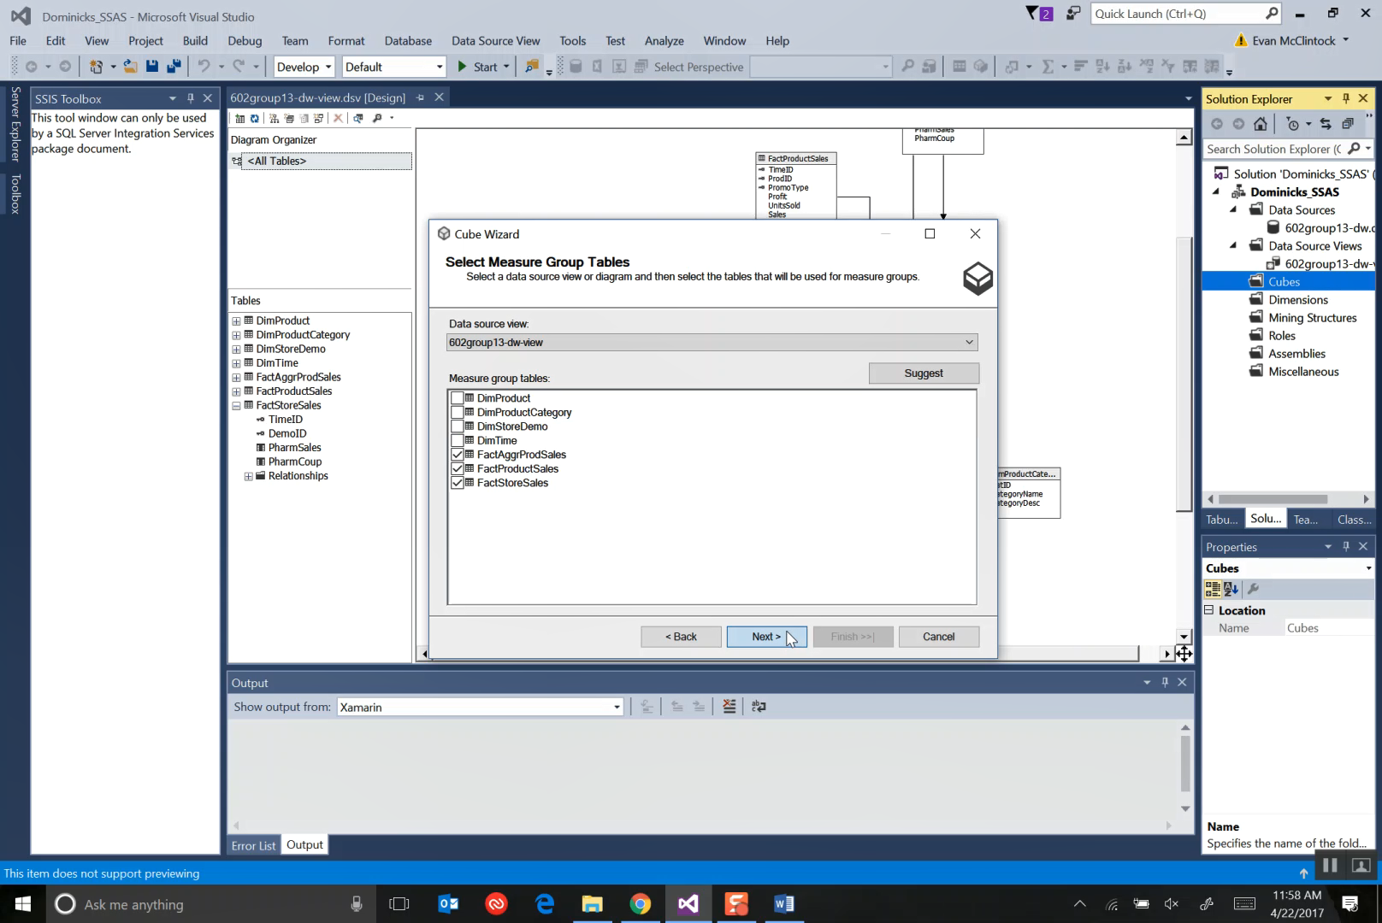*Figure 11.2.1 The screenshot above portrays the selection of selecting the measure group tables, from the Fact Tables.*

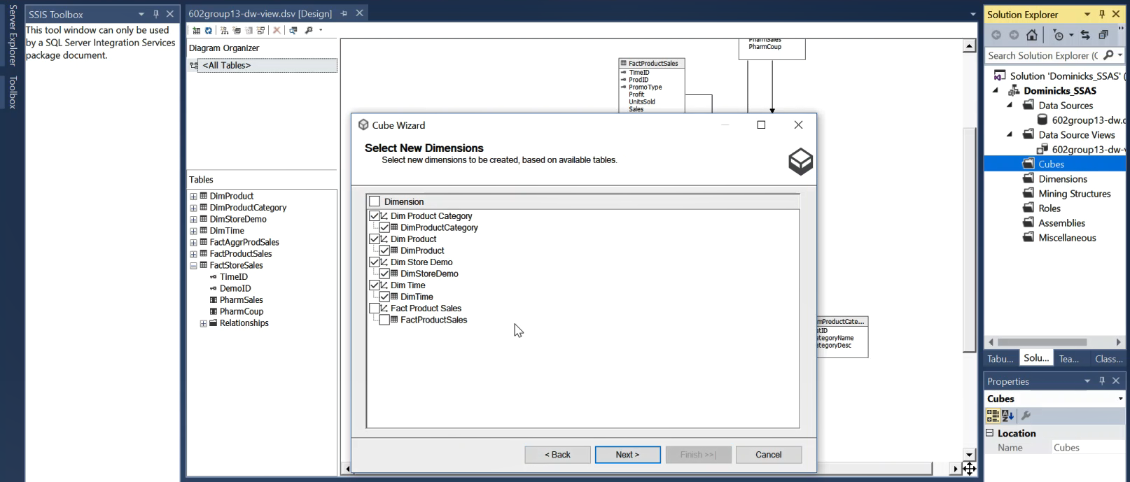*Figure 11.2.2 The screenshot above portrays the selection of selecting the dimension tables.*

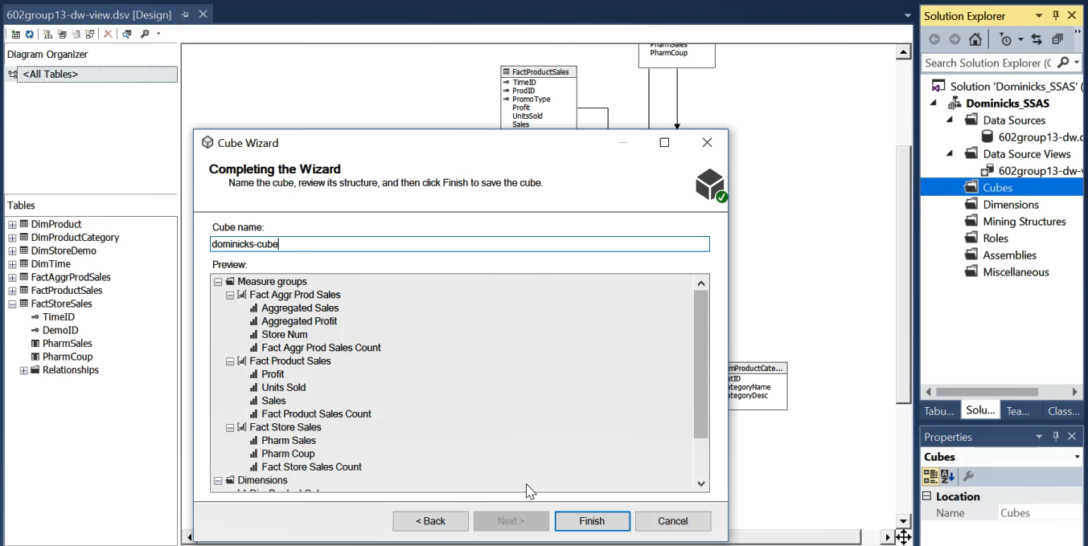

*Figure 11.2.3 Finishing the creation of “dominick’s-cube”*

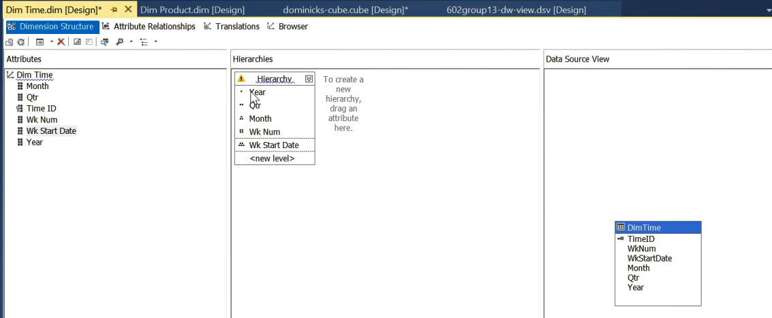

*Figure 11.2.4 Adding Hierarchies to the Time Dimension*

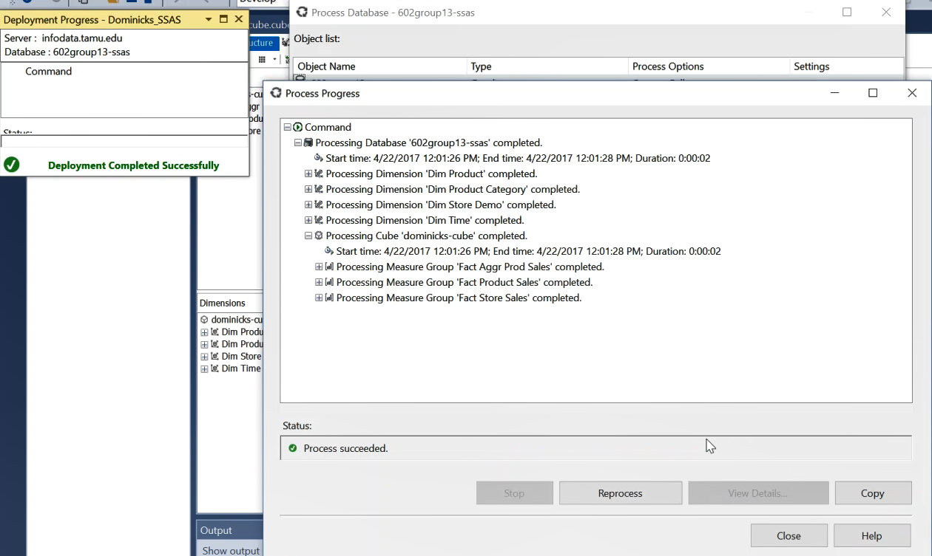

*Figure 11.2.5 Deployment and Processing of “dominick’s-cube”*

**11.3 Reporting Implementation**

**11.3.1 Question 1: Which products do we promote in our highest grossing stores?**

Figures 11.3.1.1 - 11.3.1.5 demonstrate the creation of SSRS report for answering question 1. We start by creating a data source, which is the data warehouse in this case, and then create the query in the query builder for displaying the top products and their target stores. The report first finds the top grossing stores for Dominick Finer Foods and then the top selling products for these stores. Since these products sell more than all the other products, a marginal increase in price or other promotional strategies would further increase the sales of the store.

|  |  |  |
| --- | --- | --- |
| Mapping Table | | |
| Source Table | **Column** | **Report Parameter** |
| DimStoreDemo | StoreNum | Store Number |
| FactAggrSales | AggregatedSales | Aggregated Sales |
| DimProduct | ProdName | Product Name |

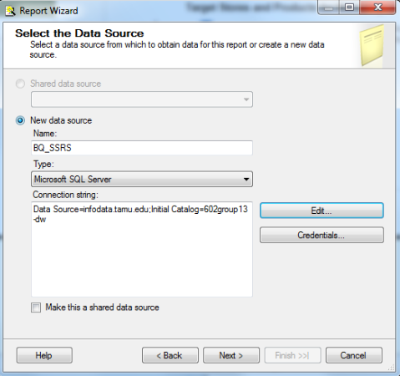

*Figure 11.3.1.1 Adding Data Source to the report*

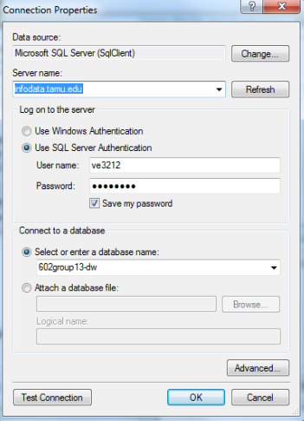

*Figure 11.3.1.2 Selecting the data warehouse*

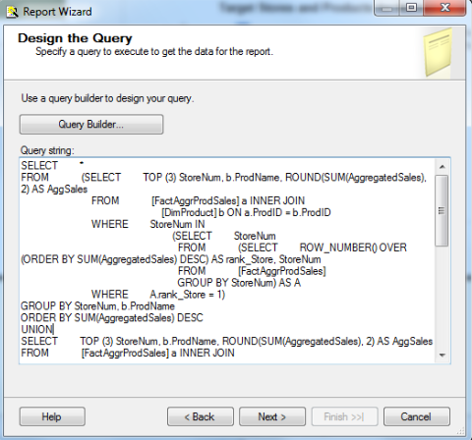

*Figure 11.3.1.3 Designed the query in Query Builder*

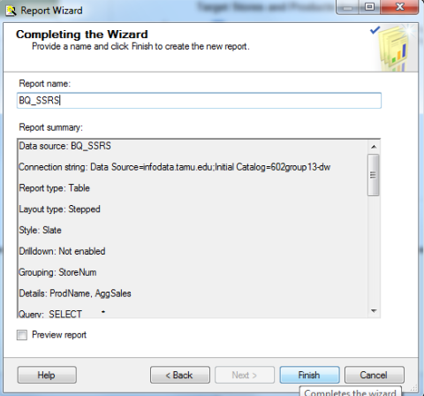

*Figure 11.3.1.4 Finishing the report creation*

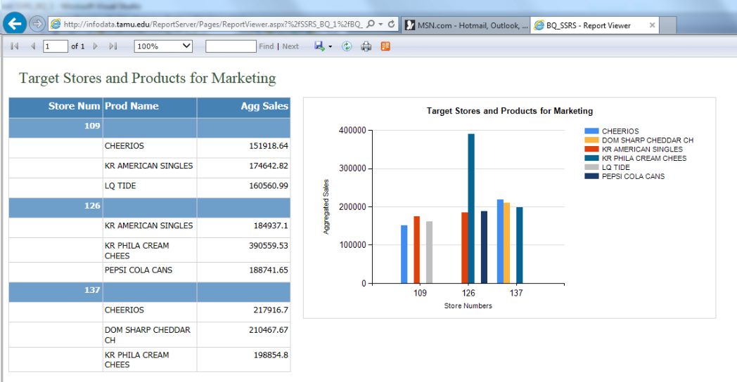

*Figure 11.3.1.5 Report Output in browser*

The report is finally deployed on infodata.tamu.edu server and then opened via browser. The bar chart clearly depicts that store number 109 should target Cheerios, KR American Singles and LQ tide.

**11.3.2 Question 3: What strategies can we implement to make sure in-house brands sell more? How does Dominick’s in-house soda brands fare against a commercial brand like Pepsi?**

We observe the weekly sales trends of in-house brands vs the most popular brands in cola and cereal categories. We create the weekly sales report and an appropriate chart in report builder to see the weekly sales trends. The figure 11.3.2.1 and figure 11.3.2.2 below show the creation of query and the designing of the report for the soda sales of Dominick’s in-house soda and Pepsi, the most selling brand at Dominick’s stores. A similar report is created for the cereals category. We compare in-house brand sales with the most selling General Mills cereal brand.

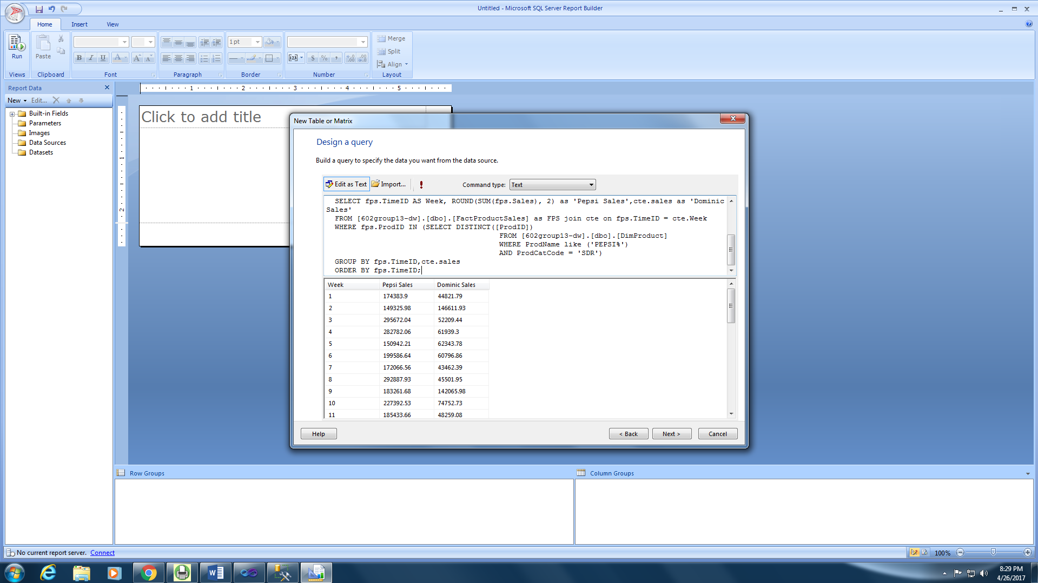

*Figure 11.3.2.1 Create the query for weekly soda sales*

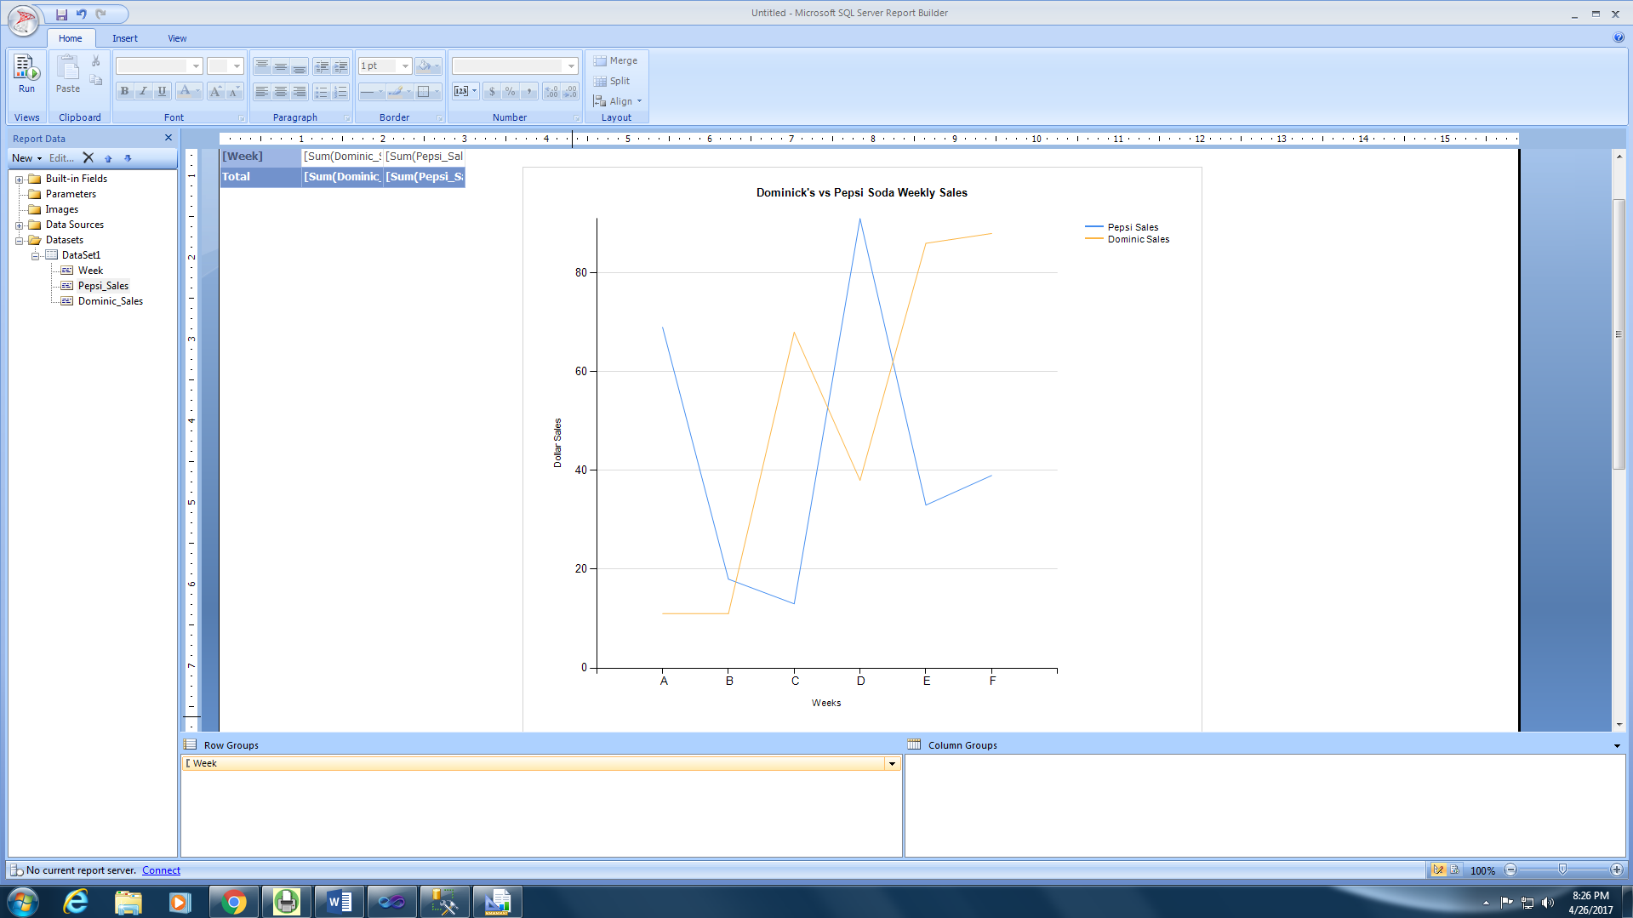

*Figure 11.3.2.2 Design the report with charts*

|  |  |  |
| --- | --- | --- |
| Mapping Table for in-house vs branded product Sales By Week | | |
| Source Table | **Column** | **Report Parameter** |
| DimProduct | BrandCode | (Category Filter) |
| FactProductSales | Sales | Sales (Sodas and Cereals) |
| DimTime | WkNum | Week |

The reports for the in-house vs branded weekly sales for sodas and for cereals can be seen in figure 11.3.2.3 and 11.3.2.4 below. The line graph for sodas shows a huge consistent difference between the sales. The gap is even more prominent in the case of cereals.

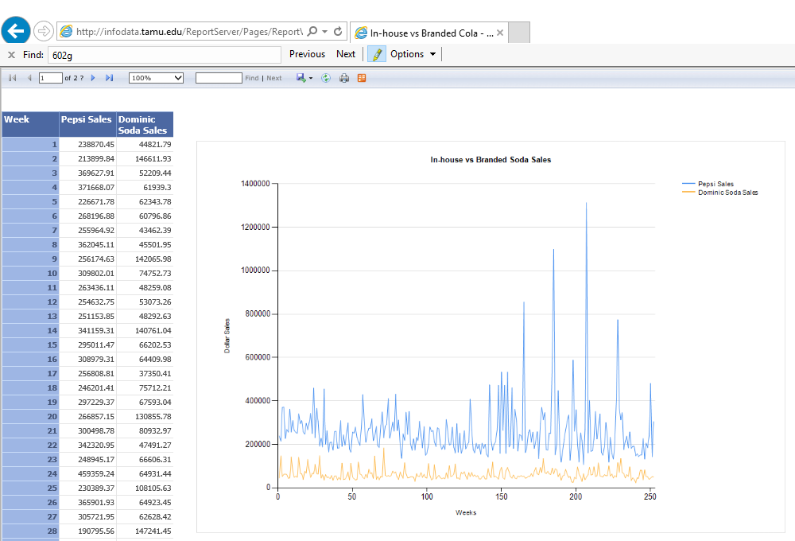

*Figure 11.3.2.3 In-house vs branded soda sales report*

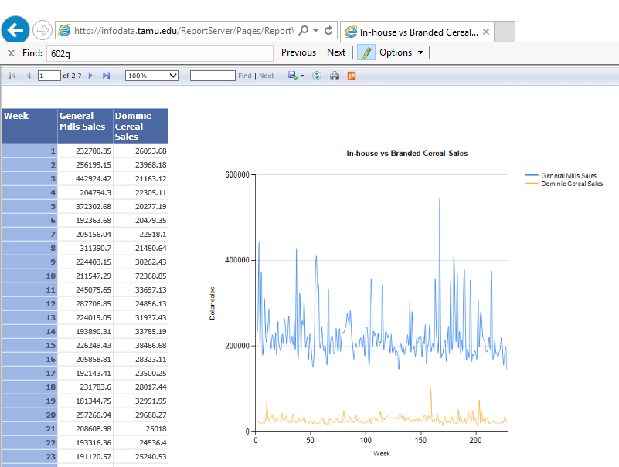

*Figure 11.3.2.3 In-house vs branded cereal sales report*

The sales trends above clearly indicate that the in-house brand sells much less, especially in case of cereals. Dominick’s should try and increase their sales by running promotions or by placing the in-house branded items in front of the isles. This way they could try and surpass the sales of popular brands and increase their profit margins.

**11.3.3 Question 5: Analyze canned soup seasonality patterns to target business strategies for peak sales seasons. Which canned soup brand is the most popular, and does its seasonality significantly affect the others?**

Figures 11.3.3.1 – 11.3.3.x demonstrate the creation of SSAS on top of SSRS reports used for answering question 5.

We start by creating a data source, which is SSAS in this case, and then create the dataset for the first report, which will show the overall trends observed for canned soups between 1992 and 1996.

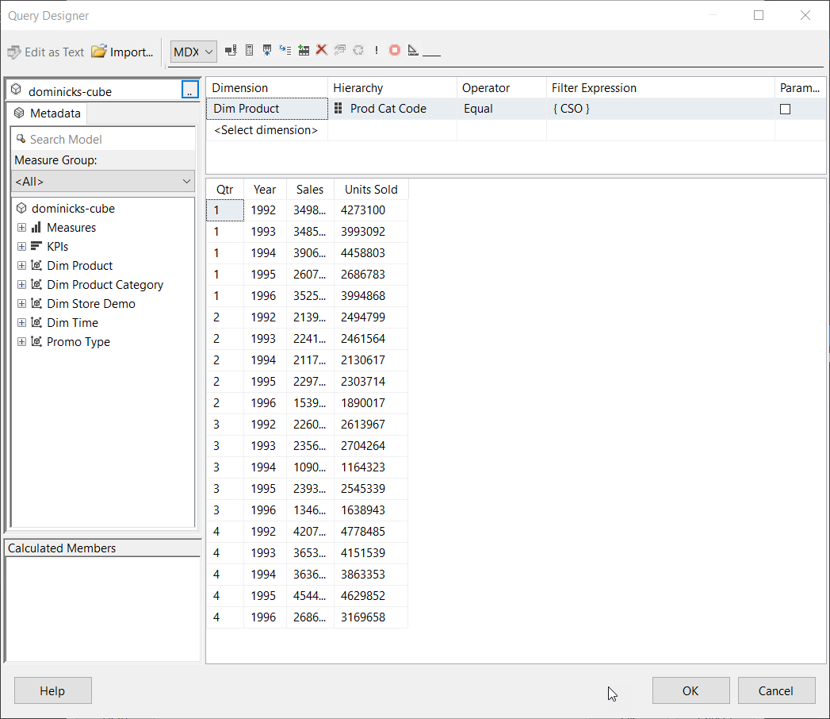

*Figure 11.3.3.1 – Creating the data source view for the first report, on Canned Soup Sales by Quarter.*

|  |  |  |
| --- | --- | --- |
| Mapping Table for Canned Soup Sales By Quarter | | |
| Source Table | **Column** | **Report Parameter** |
| DimProduct | ProdCatCode | (Category Filter) |
| FactProductSales | Sales | Sales Dollars |
| DimTime | Qtr | Quarters |
| DimTime | Year | Years |

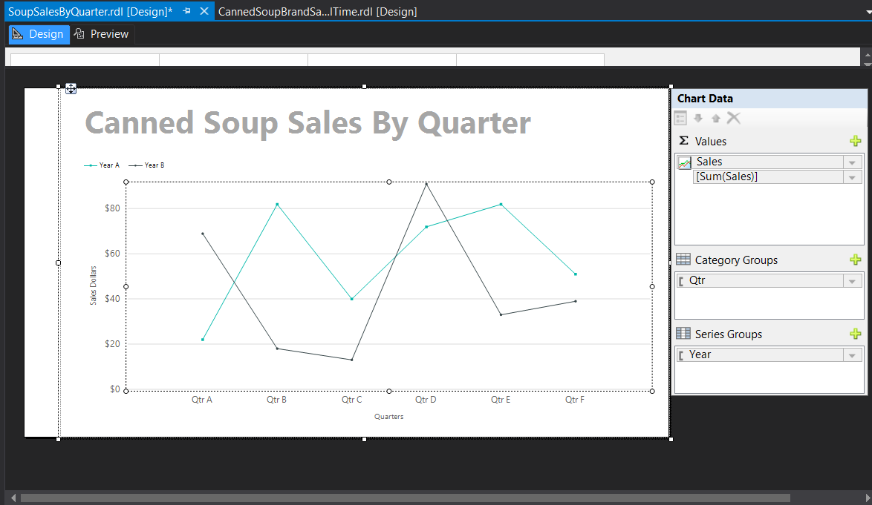

*Figure 11.3.3.2 Creating the graph which comprises the canned soup sales by quarter.*

After finishing the creation of the chart with the correct values, series and category groups, we published the report to the Report Server on infodata.tamu.edu.

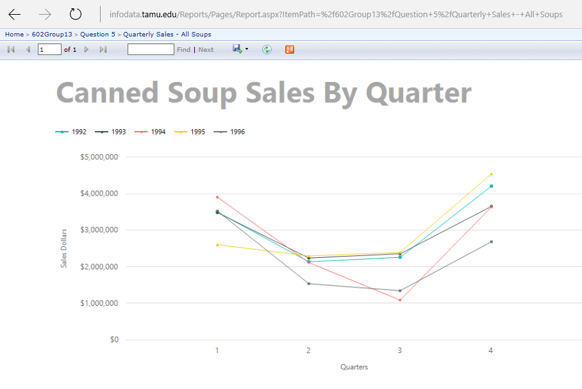

*Figure 11.3.3.3 Canned Soup Sales By Quarter in browser*

The Quarterly Sales – All Soups report graph depicts the sales dollars over all four quarters of the year, in different colors. The graph above demonstrates that there is a seasonality in canned soups of all brands during the first and fourth quarters, which comprise the winter months.

The next report would find the all-time soup sales for all the canned-soup brands to uncover which canned soup brand is the most popular sold in Dominick’s stores.

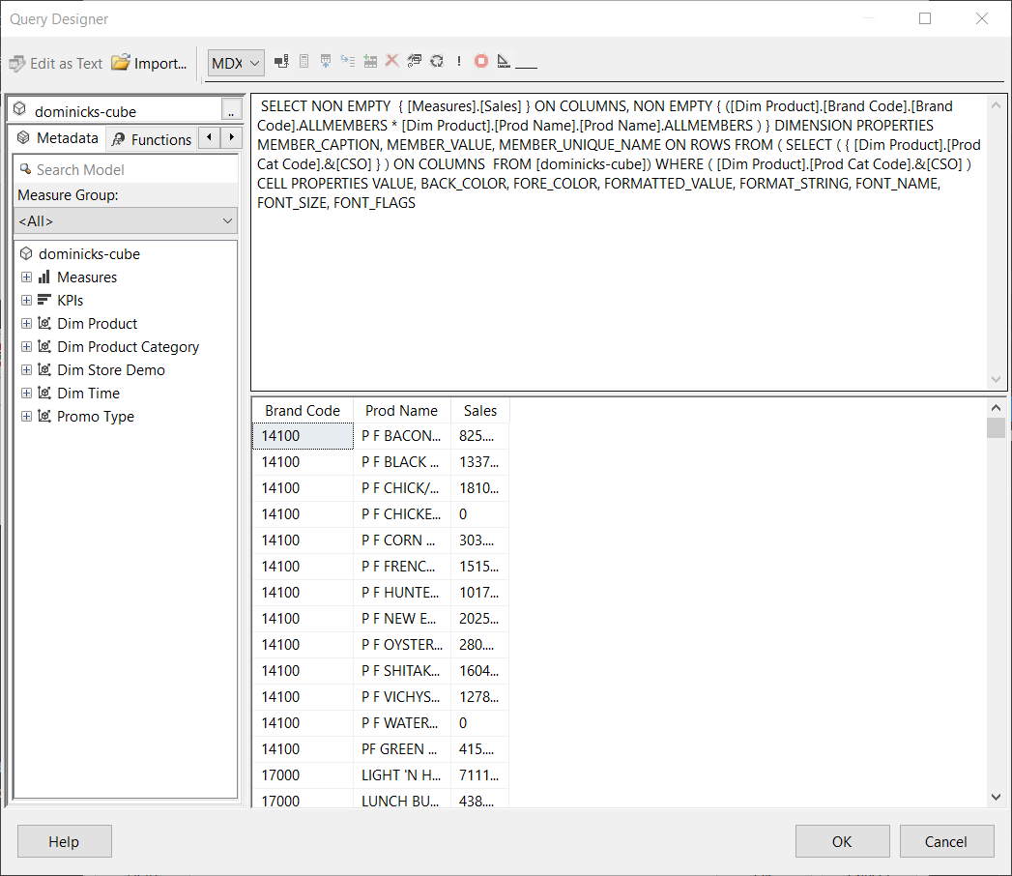

*Figure 11.3.3.4 – Creating the data source view for the second report – All Time Sales - All Soups.*

|  |  |  |
| --- | --- | --- |
| Mapping Table for All Time Sales – All Soups | | |
| Source Table | **Column** | **Report Parameter** |
| DimProduct | ProdCatCode | (Category Filter) |
| DimProduct | BrandCode | Brand Code |
| FactProductSales | Sales | Sales |

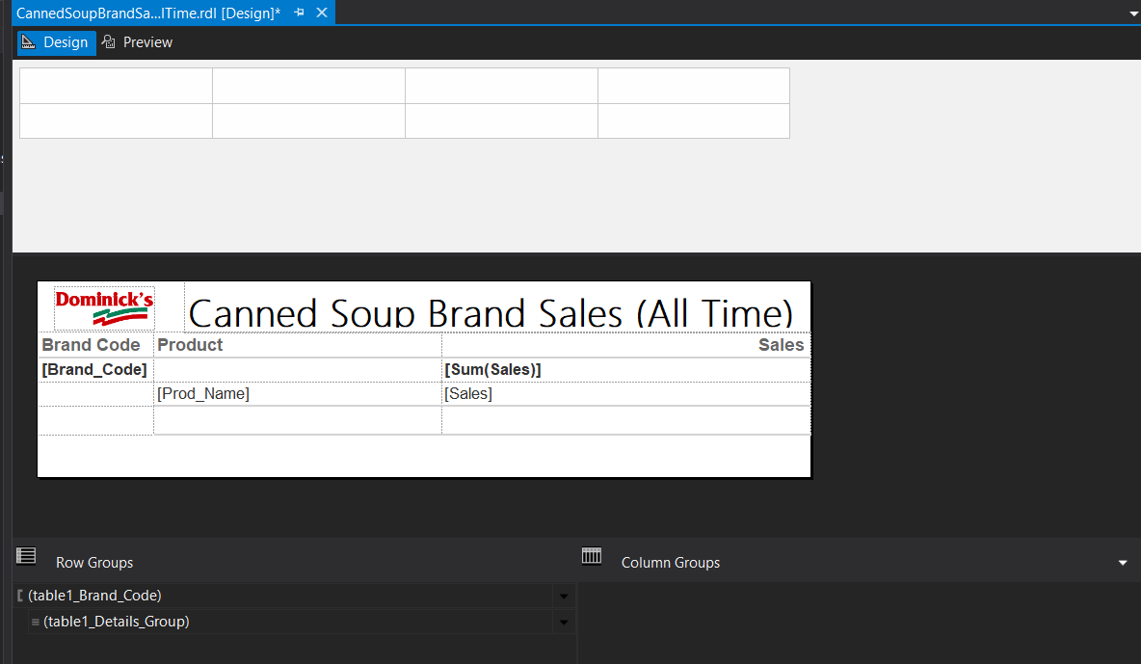

*Figure 11.3.3.5 – Editing the table for the second report – All Time Sales - All Soups.*

Subsequently, we deployed the report to infodata.tamu.edu, the report server. Figure 11.3.3.6 illustrates that we discovered that 51000 is the brand code with the highest overall soup sales. We then discovered, that brand is Campbell’s soups, with Cream of Mushroom Soup being the best-selling soup. Now that we know that Campbell’s is the best-selling soup, we could create two more charts to reflect the soup sales trends, thanks to its brand code.

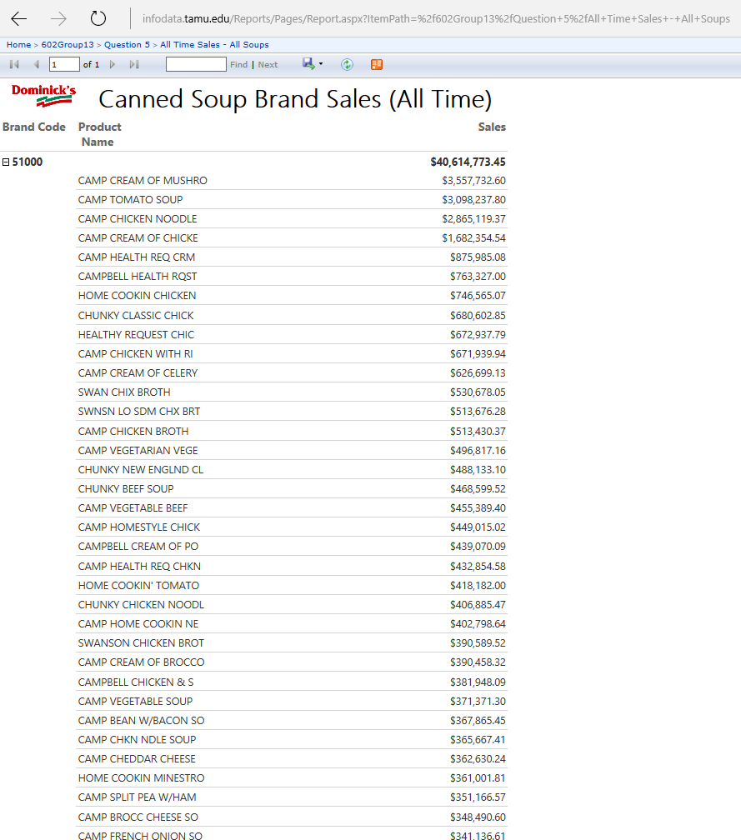

*Figure 11.3.3.6 – The second report – All Time Sales - All Soups in the browser*

We then created another table, for the Campbell’s soup brand sales by quarter.

|  |  |  |
| --- | --- | --- |
| Mapping Table for Campbells Soup Sales By Quarter | | |
| Source Table | **Column** | **Report Parameter** |
| DimProduct | ProdCatCode | (Category Filter) |
| DimProduct | ProductCatCode | (Brand Filter) |
| FactProductSales | Sales | Sales Dollars |
| DimTime | Qtr | Quarters |
| DimTime | Year | Years |

This table used a slightly modified data source view, compared to the All Canned Soup Sales by Quarter table, which is depicted in Figure 11.3.3.1. The only difference was the addition of a brand code filter, to show only Campbells brand soups. We published the end result to the server. Figure 11.3.3.7 demonstrates that the trends for Campbells perfectly follows the trend for canned soup overall.

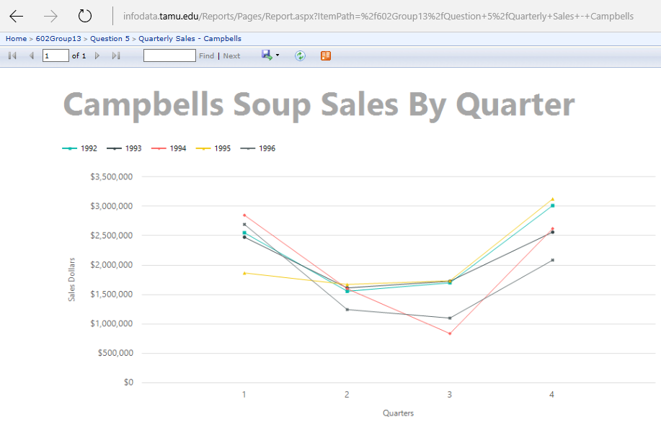

*Figure 11.3.3.7 – The third report Quarterly Sales for Campbells Soup Brand*

For the final report which covered Non-Campbells quarterly sales, we made another slight adjustment: we filtered out the Campbells soup brand to inspect the trends of the other canned soup brands, without the Campbells brand’s contribution. This will allow us to learn whether the trend would remain without Campbells.

|  |  |  |
| --- | --- | --- |
| Mapping Table for Non-Campbells Soup Sales By Quarter | | |
| Source Table | **Column** | **Report Parameter** |
| DimProduct | ProdCatCode | (Category Filter) |
| DimProduct | ProductCatCode | (Brand Filter) |
| FactProductSales | Sales | Sales Dollars |
| DimTime | Qtr | Quarters |
| DimTime | Year | Years |

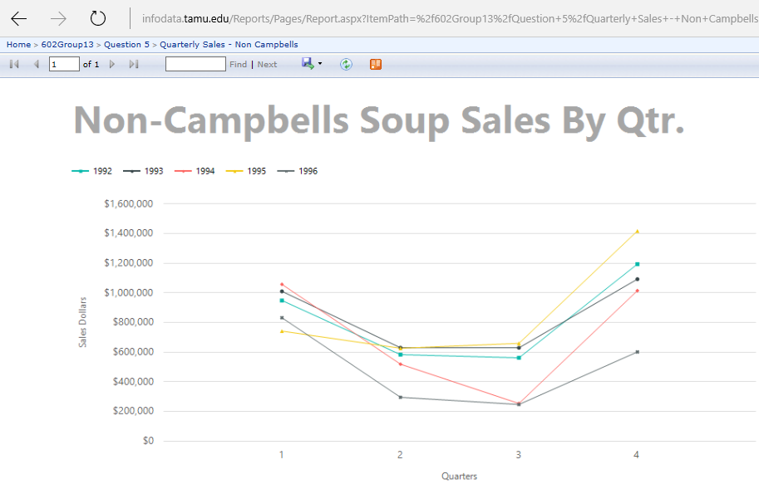

*Figure 11.3.3.8 – The fourth report Quarterly Sales for Non-Campbells Soup*

As Figure 11.3.3.8 demonstrates, the overall trend generally stays the same, with and without Campbell’s soup counted toward the graph. However, Campbells makes up so much of the soup sales, that its placement in the stores should allow customers to buy other tying or complimentary products to help Dominick’s Finer Foods increase its overall profits in the soup catergory, in addition the complimentary categories, like crackers. During the first and fourth quarters of each year, Dominck’s should consider placing Campbells top products on the endcaps of aisles, if it wishes to increase sales of soup during the winter months.

**11.3.4 Question 7: Determine which demographics need to be targeted to boost pharmacy sales.**

There are multiple demographics that can affect the sales of products. We look at the pharmacy sales for this question and we target six demographics that seem relevant to pharmacy sales. We can see the trends of the sales for top three and bottom three stores according to the specified demographic. If there is a pattern in the sales we can say that the specified demographic affects the pharmacy sales. Thus, that particular demographic can be targeted to increase the pharmacy sales. We use SSRS to create a report to see the sales of top and bottom three stores. Figure 11.3.4.1 and 11.3.4.2 below show the query design.

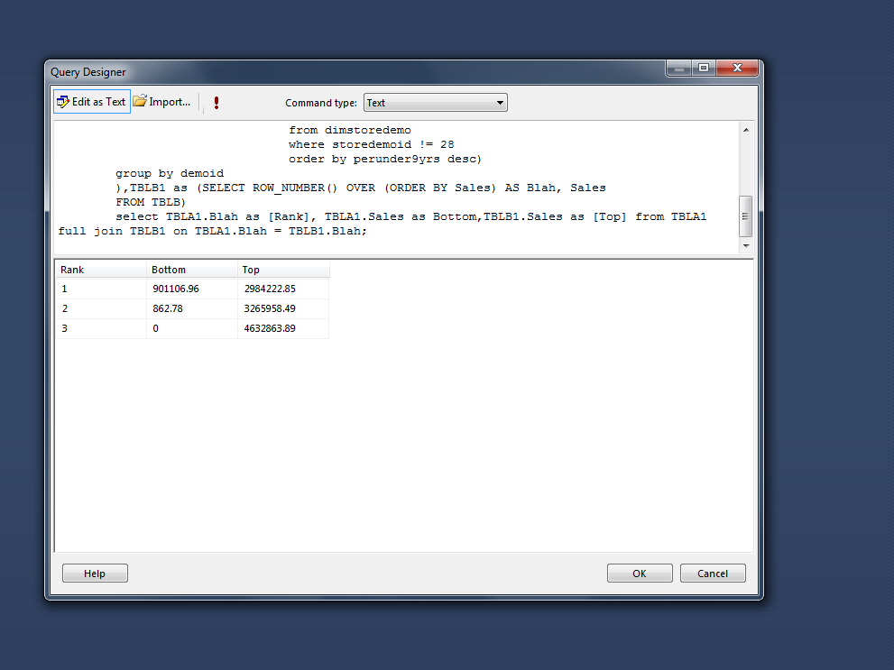

*Figure 11.3.4.1 – Create the query for top and bottom store sales for various demogrphics*

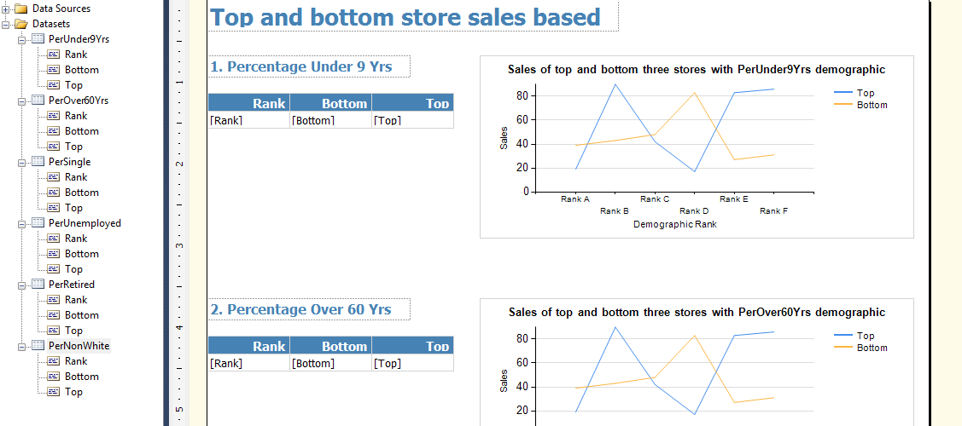

*Figure 11.3.4.2 – Design the report targetting all 6 demographics*

|  |  |  |
| --- | --- | --- |
| Mapping Table for | | |
| Source Table | **Column** | **Report Parameter** |
| FactStoreSales | PharmSales | Bottom / Top |
| DimStoreDemo | PerUnder9Yrs | PerUnder9Yrs |
| DimStoreDemo | PerOVer60Yrs | PerOVer60Yrs |
| DimStoreDemo | PerSingle | PerSingle |
| DimStoreDemo | PerUnemployed | PerUnemployed |
| DimStoreDemo | PerRetired | PerRetired |
| DimStoreDemo | PerNonWhite | PerNonWhite |

The figure 11.3.4.3 and 11.3.4.4 below shows the report with top three and bottom three stores for the target six demographics. The line graph helps to determine the trend between the sales of these stores.

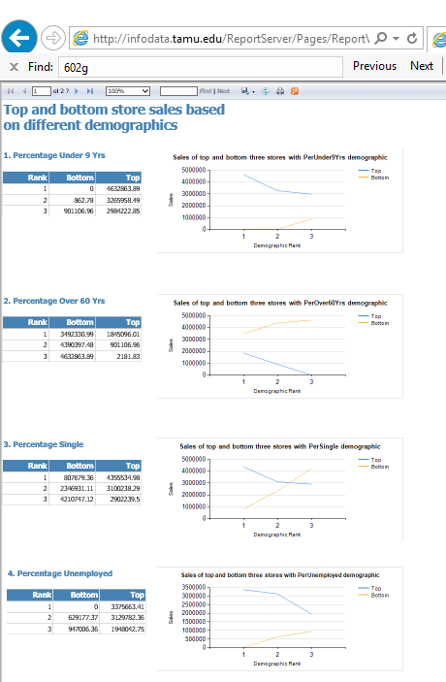

*Figure 11.3.4.3 – Report on infodata showing all demographics*

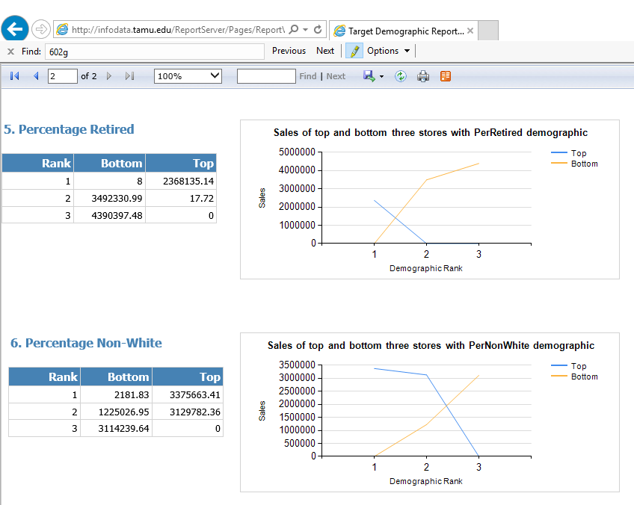

*Figure 11.3.4.3 – Report on infodata showing all demographics*

The sales of top and bottom three stores of the above demographics show that percentage under 9 years, percentage over 60 years and percentage unemployed demographics affect the pharmacy sales. Thus, these three demographics can be targeted to increase the pharmacy sales even further.

**11.3.5 Question 8: Which products would benefit from running a promotion on them and which ones would not?**

The question aims to analyze the effect of different promotion types on different product categories. Running the promotions on the right products and removing the sales from the bad ones would lead to a higher profit margin. Based on this information for different categories, DFF can target the categories or its products to further maximize sales.

|  |  |  |
| --- | --- | --- |
| Mapping Table | | |
| Source Table | **Column** | **Report Parameter** |
| DimProduct | ProdCatCode | Category Name |
| FactProdSales | Sales | Sales |
| DimProduct | Desc | Promo Type |

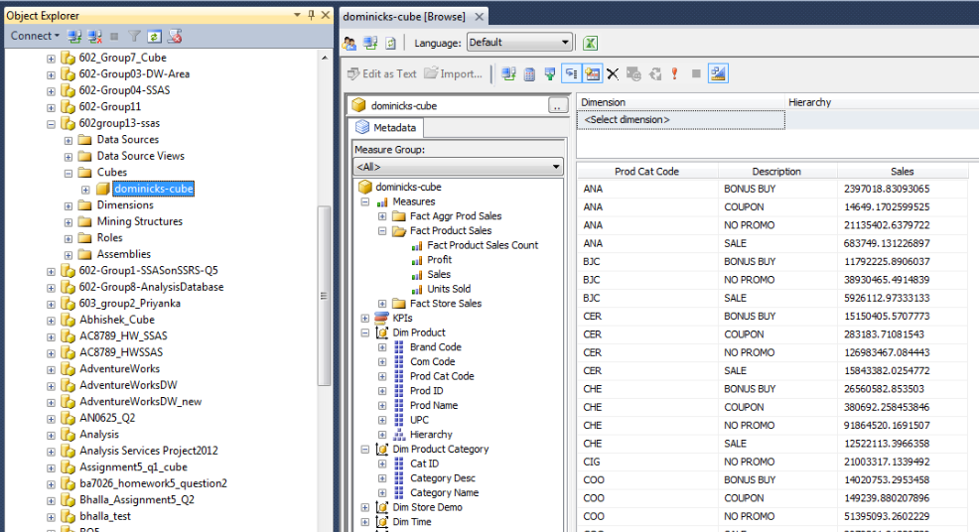

*Figure 11.3.5.1 Report Output in browser*

The above report shown in Figure 11.3.5.1 clearly shows the various categories and the sales divided by different promotional types. The report shows that the *‘Bonus Buy’* promotion worked best for analgesics and continuing this promotion would be a wise choice for the company. The report also shows that for Cereals *‘Bonus Buy’* isn’t the most effective promotion and sales are higher without this promotion going on. The marketing team can utilize this information and similar analysis for different products to further decide promotional strategy for various products and their categories. The information can also be used to re-strategize certain promotions which no longer yield any positive results for DFF.

# References

Bring on the soup. (2001). *Science and Children, 38*(4), 10. Retrieved from http://search.proquest.com/docview/236943921?accountid=7082

Crown, J. (1993, November 15). Dominick's after Dominick. *Crain's Chicago Business, 16*(46), 3. Retrieved from http://ezproxy.library.tamu.edu/login?url=http://search.proquest.com/docview/198405380?accountid=7082

Dudlicek, J. (2015). The Case for Meat. *Progressive Grocer, 94*(11), 126-130. Retrieved from http://search.ebscohost.com/login.aspx?direct=true&db=voh&AN=110842036&site=eds-live

Meza, S., & Sudhir, K. (2010, May 14). Do private labels increase retailer bargaining power? *Quantitative Marketing and Economics*, 333–363. Retrieved from http://www.springerlink.com/content/65428p5811380528/fulltext.pdf

Peltzman, S. (2000, June). Prices Rise Faster than they Fall. *The Journal of Political Economy, 108*(3), 466-502. Retrieved from https://research.chicagobooth.edu/marketing/databases/dominicks/docs/2000-PricesRiseFaster.pdf

University of Chicago Booth School of Business. (2013, July). *Dominick’s Data Manual*. Retrieved from Kilts Center for Marketing.